

**Table of Contents**

**1. CHAPTER 1: INTRODUCTION TO THE STUDY** 5

**1.1. Background to the project** 5

**1.2. Problem context** 7

**1.3. Rationale** 10

**1.4. Potential benefits** 11

**1.4. 2. Intangible benefits** 12

**1.5. Target users** 13

**1.6. Scope and objectives** 14

**1.6. 1. Aims** 14

**1.6. 2. Objectives** 14

**1.6. 3. Deliverables - Functionality of the proposed system** 15

**1.6. 4. Nature of Challenges** 16

**1.7. Overview of this Investigation report** 16

**1.8. Project Plan** 17

**2. CHAPTER 2: LITERATURE REVIEW** 17

**2.1. Introduction** 17

**2.2. Domain research** 18

**2.2.1. Technology in early childhood education** 18

**2.2.2. Pedagogy and Early Mathematics Learning** 19

**2.2.3. Child Development and Learning** 20

**2.2.4. Play-Based Learning** 21

**2.3. Similar Systems** 22

**2.3.2. ABCmouse** 23

**2.4. Summary** 24

**3. CHAPTER 3: TECHNICAL RESEARCH** 24

**3.1. Programming language chosen** 24

**3.2. IDE chosen** 25

**3.3. libraries chosen / Tools chosen** 26

**3.4. Operating System chosen** 27

**3.5. Summary** 27

**4. CHAPTER 4: SYSTEM DEVELOPMENT METHODOLOGY** 27

**4.1. System Development Methodology Chosen** 27

**4.2. Overview of the diagrams** 28

**4.3. Overview of how this project will proceed** 29

**5. CHAPTER 5: RESEARCH METHODS** 30

**5.1: Introduction** 30

**5.1.1. The importance and necessity of data collection** 30

**5.1.2. Choice of Data Collection Method** 30

**5.2 Design** 31

**5.2 Summary** 36

**6. CHAPTER 6: REQUIREMENTS VALIDATION** 37

**6.1 Analysis of Data** 37

**6.1.1 Analysis of data collected through Questionnaire** 38

**6.2 Summary** 42

**7. CHAPTER 7: SYSTEM ARCHITECTURE** 42

**7.1. Introduction** 42

**7.2. System Design** 43

**7.2.1. Function Design** 43

**7.2.2. Use Case Diagram** 46

**7.2.3. Activity Diagram** 47

**7.3. Model Training** 52

**7.3.1. Data collection** 52

**7.3.2. Data preprocessing** 52

**7.3.3. Data Partitioning** 53

**7.3.4. Model Selection** 53

**7.3.5. Model Training** 54

**7.3.6. Training Result** 55

**7.4. Database design** 56

**7.5. UI Design** 58

**8. CHAPTER 8: Project Plan** 63

**8.1 Details of the release plan** 63

**8.1.1 Version 1.0 of your project title** 63

**8.1.2 Version 2.0 of your project title** 63

**8.2. Function Useable Test** 63

**8.3. Test plan for User Acceptance Testing** 66

**9. CHAPTER 9: Implementation** 68

**9.1 UI Design** 68

**9.2 Sample Codes** 79

**9.2.1 Libraries** 80

**9.2.2 UI manage** 83

**9.2.3 Detection model processing** 85

**9.2.4 Open the image for detection** 87

**9.2.5 Random Algorithm Generation** 88

**9.2.6 Real-time detection thread** 89

**9.2.7 Processing Expressions** 91

**9.2.8 Voice Broadcast** 93

**9.2.9. Database** 94

**10. CHAPTER 10: SYSTEM VALIDATION** 95

**10.1 UI Testing** 95

**10.2 Function Testing** 97

**10.3 User Acceptance Testing** 100

**10.3.1 A teenager** 100

**10.3.2 Mother of a preschool child** 102

**10.3.3 A 7-year-old child** 103

**10.4 Summary** 104

**11. CHAPTER 11: CONCLUSION AND REFLECTIONS** 105

**11.1 Critical Evaluation** 105

**11.2 Summary and Conclusion** 106

**12. REFERENCES** 108

**13. APPENDICES** 117

**Log sheets** 117

**PPF** 123

**Ethics form** 125

**Gantt chart for semester 1** 128

**Gantt chart for semester 2** 128

**Poster** 129

# **1. CHAPTER 1: INTRODUCTION TO THE STUDY**

## **1.1. Background to the project**

Education has been a cornerstone of human development and has been an essential component of human society since ancient times. The Chinese civilization, for example, has a long history of valuing education and developing a systematic education system for children. According to Confucianism, education was considered the foundation for moral development and the cultivation of social order. The Chinese education system was designed to instill a strong sense of discipline, respect, and hard work in children from a very young age. This tradition has continued to this day, and Chinese parents still value education as the key to their children's success.

With the advancement of technology and the growing importance of knowledge-based industries, education has become even more critical. Today, there is an increasing emphasis on children's education, and parents are willing to spend a significant amount of money and time to ensure their children receive the best education possible. However, this has led to the development of a variety of tutoring classes for children, including music, elocution, logic, and Olympiads, which may cause children to feel overwhelmed and bored.

Research has shown that excessive pressure and competition in the education system can have negative effects on children's mental health and well-being. A study by Wu et al. (2020) found that excessive academic pressure and competition are linked to increased levels of anxiety and depression in Chinese high school students. Similarly, a study by Wang et al. (2020) found that Chinese parents' emphasis on their children's academic achievements is linked to lower levels of life satisfaction in children.

Furthermore, studies have shown that excessive tutoring can have a detrimental effect on children's creativity and independent thinking skills. A study by Wang et al. (2019) found that excessive tutoring is linked to a decrease in children's creativity and intrinsic motivation. Another study by Hu et al. (2020) found that excessive parental involvement in children's education can lead to a decrease in children's autonomy and independence.

The issue of excessive tutoring and pressure in education is not unique to Chinese society but is also prevalent in other societies, including Malaysia. In recent years, there has been a growing trend of parents enrolling their children in various tuition classes and extracurricular activities to enhance their academic performance and future prospects. This has created a highly competitive and stressful environment for children, which may lead to negative consequences for their mental health and overall well-being.

Studies conducted in Malaysia have shown that excessive academic pressure can lead to increased levels of stress, anxiety, and depression in children. A study by Puan et al. (2020) found that the pressure to perform well academically was a significant source of stress for Malaysian students. Furthermore, another study by Wong et al. (2021) found that academic pressure and parental expectations were significant predictors of anxiety and depression symptoms in Malaysian secondary school students.

Moreover, the excessive emphasis on academic performance may also hinder children's personal growth and development. Studies have shown that excessive tutoring and structured activities can limit children's opportunities for creative and independent thinking, which are essential skills for their future success. A study by Tan and Chua (2019) found that excessive tutoring and parental control were linked to lower levels of creativity and self-efficacy in Malaysian primary school students.

Excessive academic pressure and competition in education are not limited to Chinese and Malaysian societies but are a worldwide phenomenon. Many parents believe that their children's success in education is crucial for their future prospects and are willing to go to great lengths to ensure their children receive the best education possible. However, the pressure to succeed in education can have negative effects on children's mental health and well-being, including increased levels of stress, anxiety, and depression.

Studies have shown that excessive pressure in education can also hinder children's personal growth and development by limiting their opportunities for creative and independent thinking. This is particularly concerning given that these skills are becoming increasingly important in the 21st century, where the ability to think critically and creatively is essential for success in knowledge-based industries.

To address this issue, there are several methods of enlightenment for children in need, including providing children with opportunities for unstructured play and exploration, encouraging curiosity and creativity, and fostering a love of learning. Parents and educators can also help children develop important life skills such as resilience, self-regulation, and self-efficacy, which can help them cope with academic pressure and navigate the challenges of modern life.

In addition to these methods, there are also educational software programs that can help children develop these skills. For example, there are programs that focus on developing children's creativity, problem-solving, and critical thinking skills, such as Scratch and Tynker. There are also programs that focus on social-emotional learning, such as Class craft and Mood Meter, which can help children develop important life skills such as empathy, self-awareness, and self-management.

In conclusion, excessive pressure and competition in education can have negative effects on children's mental health and well-being and limit their opportunities for personal growth and development. To address this issue, parents and educators can provide children with opportunities for unstructured play and exploration, encourage curiosity and creativity, and foster a love of learning. Additionally, there are educational software programs that can help children develop important skills such as creativity, problem-solving, and social-emotional learning.

## **1.2. Problem context**

Preschool Mathematics Education Based on Image Detection is an innovative approach to teaching young children mathematics. With the increasing use of technology in education, it is becoming more important to integrate these advancements into preschool education. The purpose of this approach is to make learning more engaging and interactive for children by incorporating image detection technology.

In today's society, young children are often exposed to technology from a very young age. However, traditional teaching methods can be uninteresting and ineffective for preschool children who are still developing their cognitive and motor skills. Children may become disinterested or frustrated with traditional methods, leading to negative attitudes towards learning. Therefore, there is a need for a more engaging approach to teaching preschool mathematics.

Furthermore, young children often have short attention spans and require interactive learning experiences to maintain their focus. By utilizing image detection technology, educational software can be designed to provide interactive and fun learning experiences for children. This technology can recognize the child's actions and provide feedback in real-time, making the learning process more engaging and exciting.

However, there are several challenges that need to be addressed when implementing this approach. Firstly, it is important to ensure that the software is age-appropriate and suitable for young children. The educational content needs to be presented in a way that is easily understandable and enjoyable for preschoolers. Secondly, the use of technology in preschool education raises concerns regarding screen time and the potential negative effects on children's health and development. Therefore, it is important to design the software in a way that promotes healthy screen time habits and incorporates physical activity.

1. Limitation of the current teaching method in the preschool education

Based on this question, the problem statement is that the current teaching methods in preschool education have limitations in effectively teaching mathematics to young learners. While traditional methods such as using flashcards, counting objects, and singing songs can be effective, they may not fully engage and challenge children in the learning process. Additionally, these methods may not provide enough opportunities for children to develop problem-solving and critical thinking skills.

Several studies have highlighted the limitations of traditional teaching methods in preschool mathematics education. For example, a study by Stipek and Byler (2001) found that rote learning methods, such as memorization of math facts, did not improve children's understanding of mathematical concepts. Another study by Clements and Sarama (2014) noted that traditional math teaching methods often focus on simple counting and recognition of numbers, rather than more complex mathematical concepts.

Therefore, there is a need to explore alternative teaching methods that can effectively engage young learners in mathematics education. One potential solution is to incorporate image detection technology into preschool mathematics education. This technology can provide interactive and personalized learning experiences for children, while also promoting problem-solving and critical thinking skills.

2. Less of motivation of preschool children in learning the mathematic

Preschool mathematics education faces the challenge of low motivation among children to learn mathematics. Children at this age have limited attention spans, and traditional teaching methods can become monotonous and uninteresting, leading to disengagement and lack of motivation. This lack of motivation can hinder their learning and negatively impact their future academic performance.

Several studies have explored the issue of low motivation among preschool children in mathematics learning. A study by Wang et al. (2019) found that preschoolers showed less motivation in mathematics activities than in other activities, such as storytelling and drawing. The researchers suggest that this lack of motivation is due to children's perceptions of mathematics as difficult and unrelated to their daily lives. Additionally, children's attitudes towards mathematics may be influenced by their parents' attitudes and beliefs about the subject (Jacobs et al., 2014).

Moreover, traditional teaching methods that rely heavily on memorization and repetition can further contribute to low motivation and disengagement among preschoolers. These methods may not be effective in developing children's conceptual understanding of mathematics, which is crucial for their future success in the subject (Sarama et al., 2012).

3. Preschool children are weak in the cognitive and problem-solving skills.

Preschool children are weak in cognitive and problem-solving skills, which negatively affects their ability to learn mathematics.

Preschool children are in the early stages of their cognitive development and have limited problem-solving skills. This can lead to difficulties in learning mathematics, which is a subject that requires strong problem-solving abilities. Traditional teaching methods may not be effective in helping preschool children develop these skills, as they may be too abstract or difficult to understand.

## **1.3. Rationale**

The education system for preschoolers is in need of improvement, particularly in the area of providing personalized learning experiences. One way to achieve this is through the use of image analysis technology, which can provide valuable insights into the learning patterns and preferences of individual children. However, currently, there is a lack of focus on image analysis technology in preschool education. This presents an opportunity for research and development in this area to address this gap and provide a solution to the existing challenges.

By implementing image analysis technology, preschool educators can gain a deeper understanding of children's learning behaviors and preferences, leading to the creation of tailored educational programs that cater to individual needs. The technology can be used to track children's progress, identify areas of strengths and weaknesses, and provide personalized feedback. Additionally, it can help educators identify learning difficulties and provide early intervention to prevent these difficulties from becoming more severe.

Furthermore, image analysis technology can be used to create a more engaging and interactive learning environment for preschoolers, leading to increased attention and engagement during educational activities. This can help address the issue of poor attention span among preschoolers and improve their learning outcomes. Additionally, it can provide valuable insights into the effectiveness of teaching methods and materials, leading to continuous improvement of the preschool education system.

In summary, the current state of the preschool education system highlights the need for a more personalized and effective learning approach. Image analysis technology provides a potential solution to this problem, but currently, there is a lack of focus on this technology in preschool education. Through research and development in this area, the existing challenges can be addressed, leading to a more engaging, effective, and personalized learning experience for preschoolers.

## **1.4. Potential benefits**

The use of AI-based image analysis and recognition technology in preschool education can offer several tangible and intangible benefits. Tangible benefits include improved efficiency in teaching, accurate assessment of student progress, and cost savings by reducing the need for manual grading. Intangible benefits include enhanced creativity, critical thinking skills, and improved social development in preschoolers. The use of this technology can also provide teachers with valuable insights into each student's learning style, allowing for personalized instruction. Additionally, the incorporation of technology in preschool education can help prepare children for the digital age and equip them with necessary skills for future success.

**1.4. 1. Tangible benefits**

1. Improved learning outcomes: Image detection technology can help to create a more interactive and engaging learning environment for preschoolers. By using visual aids and digital tools, it can enhance their understanding of mathematical concepts and improve their learning outcomes.

2. Time-saving: Automating the process of assessing and evaluating the performance of preschoolers in mathematics can save time for teachers and parents. Instead of manually grading papers or observing children's progress, image detection technology can provide real-time feedback on their performance, allowing for immediate interventions and improvements.

3. Cost-effective: Using image detection technology in preschool education can also be cost-effective in the long run. While there may be initial costs associated with acquiring the necessary technology and training, it can eventually reduce the need for additional staff and resources, as well as reduce the amount of paper and printing materials needed.

4. Standardization: Image detection technology can help to standardize the teaching and learning process in mathematics education, ensuring that all preschoolers receive the same level of instruction and assessment. This can help to eliminate inconsistencies and disparities in learning outcomes and ensure that all children are on the same level.

5. Customization: Image detection technology can also be used to customize the learning experience for individual preschoolers. By analyzing their performance data, the technology can identify areas where a child may need more support or challenge, and provide personalized learning materials accordingly.

Overall, the tangible benefits of using image detection technology in preschool mathematics education are significant. They can help to improve learning outcomes, save time and costs, standardize the learning process, and provide customized learning experiences for individual children.

### **1.4. 2. Intangible benefits**

1.Improved engagement and motivation: Introducing image detection technology in preschool mathematics education can make the learning process more engaging and interesting for young children. By incorporating images and videos, children can learn through visual representations, which can help them better understand abstract concepts.

2. Increased confidence: By using image detection technology, preschoolers can receive immediate feedback on their performance, helping them build confidence and self-esteem. This can encourage them to continue learning and improve their skills.

3. Improved critical thinking and problem-solving skills: By engaging in hands-on activities using image detection technology, preschoolers can develop critical thinking and problem-solving skills. This can help them not only in mathematics but also in other areas of life.

4. Enhanced creativity: Image detection technology can allow preschoolers to express their creativity in a new way. They can use digital tools to create their own images and videos, which can help them develop their artistic abilities.

5. Personalized learning: Image detection technology can also help personalize the learning experience for each child. The technology can be used to track each child's progress and adjust the difficulty level of the material accordingly. This can help ensure that each child is challenged but not overwhelmed.

6. Improved collaboration: Image detection technology can also be used to promote collaboration among preschoolers. Children can work together on projects, share their ideas, and learn from one another. This can help them develop social skills and work effectively in groups.

Overall, the intangible benefits of using image detection technology in preschool mathematics education can have a significant impact on a child's development and learning experience. By enhancing engagement, building confidence, developing critical thinking and problem-solving skills, encouraging creativity, personalizing learning, and promoting collaboration, preschoolers can be better equipped for success in the future.

## **1.5. Target users**

The primary users are preschoolers. By using image detection technology, this system can make math education more engaging and accessible to young children. Here are some potential benefits that could help preschoolers get interested in learning:

Visual learning: Preschoolers are often visual learners and can better understand concepts when they see them in action. By using image detection technology, the system can help children visualize math concepts and make learning more engaging and interactive.

Personalized learning: The system can adapt to each child's learning style and pace, providing personalized learning experiences that cater to their individual needs. This can help children feel more invested in their learning and encourage them to explore and discover math concepts on their own.

Gamification: Gamifying math education can help preschoolers stay motivated and interested in learning. By incorporating game-like features such as rewards, points, and badges, the system can make learning feel like a fun activity rather than a chore.

Early exposure: Introducing math concepts to preschoolers can help them build a strong foundation for future learning. By using image detection technology, the system can help preschoolers understand math concepts such as counting, shapes, and patterns in a fun and engaging way.

Overall, the use of image detection technology in preschool mathematics education can provide a more engaging and accessible learning experience for young children, helping them develop a love for learning and a strong foundation for future academic success.

## **1.6. Scope and objectives**

Scope refers to the boundaries and limitations of a project or a task, outlining what is included and excluded from the project. Objectives, on the other hand, refer to the specific goals and targets that a project aims to achieve. Objectives are the desired outcomes of a project, while the scope defines the boundaries within which the objectives will be achieved.

### **1.6. 1. Aims**

Mathematics can often be a daunting and intimidating subject for young children. In order to prevent children from becoming bored or disengaged with mathematics, the aim of this project is to use image recognition technology to inspire preschoolers and help them better understand mathematical concepts. By using image detection to teach mathematical concepts, children can gain a deeper understanding of abstract concepts and make connections to real-world objects and scenarios. The ultimate goal is to make mathematics more accessible and enjoyable for young children, encouraging them to develop a love for learning and to pursue their education with enthusiasm and excitement. Through this project, children can gain a stronger foundation in mathematics that will set them up for success in their future academic and professional pursuits.

### **1.6. 2. Objectives**

Here are some objectives for the topic of using image recognition technology to inspire preschoolers about mathematics:

To develop an interactive and engaging mathematics curriculum for preschoolers by implementing the games concept in the proposed system.

To implement the image recognition technology in the proposed system to improve the accuracy of detecting the visual objects e.g., animals, so that it can help the preschool child to early recognize the objects and use them in the calculation equation to improve their mathematics learning experiences.

To incorporate the text-to-speech technology into the solution guide section so that it can help preschoolers better understand problem solving instead of reading the solution in text with their eyes.

These objectives can help guide the project and ensure that it is focused and achievable.

### **1.6. 3. Deliverables - Functionality of the proposed system**

To further enhance the image detection program, the system will be developed with an intuitive user interface, allowing preschoolers to easily navigate and interact with the program. The user interface will be designed to be engaging and visually appealing to captivate the attention of children and maintain their interest in learning math.

In addition to detecting equations and calculating them, the program will also incorporate various interactive features to make learning math more fun and engaging for preschoolers. For example, the program could include interactive games that help children develop their problem-solving and critical thinking skills through math-related puzzles and challenges.

The program will also have a stage learning outcome detection function, which will provide real-time feedback to children on their progress and areas that need improvement. This will help children to stay motivated and feel a sense of accomplishment as they work towards mastering math concepts.

Moreover, the program will have a built-in learning database that includes a wide range of mathematical concepts, from basic counting and addition to more advanced concepts like fractions and geometry. This will allow preschoolers to progress at their own pace and learn at a level that is appropriate for their individual skill level.

Overall, the image detection program with an intuitive user interface and interactive features will not only make learning math more fun and engaging for preschoolers but will also help them develop important skills that will be valuable throughout their lives.

### **1.6. 4. Nature of Challenges**

The nature of the challenge in developing an image detection program for preschool mathematics education is multi-faceted. Firstly, the challenge of language barriers needs to be addressed. The program needs to be designed in a way that is language-independent and able to detect mathematical concepts and equations in different languages accurately.

Secondly, the challenge of detection accuracy needs to be taken into consideration. The program needs to be able to accurately detect mathematical equations and objects even in challenging conditions, such as poor lighting or cluttered backgrounds.

Lastly, the challenge of messy handwriting and strange object shapes needs to be addressed. Preschoolers are still developing their fine motor skills, which can result in messy handwriting that may be difficult for the program to detect. In addition, preschoolers may use unconventional objects to represent numbers and equations, which can also pose a challenge for the program. Therefore, the program needs to be designed with advanced image recognition technology that can accurately detect even the messiest handwriting and most unconventional objects.

## **1.7. Overview of this Investigation report**

Investigation Report should include these part

Introduction: Begin with an overview of the project and its goals, along with a brief background of the problem you are trying to solve.

Problem Context: Discuss the key problem that you intend to solve through your project, and explain why it is important to solve this problem.

Literature Review: Conduct a thorough literature review of the domain areas related to your project, including machine learning, image recognition, and education. Summarize the key findings from your research and provide a critical analysis of the available literature.

Technical Research: Provide details on the tools, frameworks, and libraries that you will be using in your project. Compare the pros and cons of different options and explain why you chose the specific tools that you did.

System Development Methodology: Describe the methodology you will be using for your project's design and implementation. Compare different methodologies and explain why you chose the specific methodology that you did.

Research Methods: Explain the research methods that you used to gather requirements for your project, and justify your chosen method. Analyze the gathered data to validate and justify the requirements.

Results: Present the results of your project, including any data analysis, visualizations, and user feedback.

Conclusion: Summarize the main findings of your project, along with any limitations and future work. Reflect on the strengths and weaknesses of your project and provide recommendations for future research.

## **1.8. Project Plan**

Shown at the end of the article

# **2. CHAPTER 2: LITERATURE REVIEW**

## **2.1. Introduction**

The field of education has been continuously evolving over the years, and with the advancements in technology, new and innovative teaching methodologies are emerging. One such technology that has the potential to revolutionize the education sector is image recognition. Image recognition technology involves using computer algorithms to identify and classify objects within digital images or videos. The potential applications of this technology in education are vast, particularly in the area of early childhood education. By providing a visual and interactive learning experience, image recognition technology has the potential to engage young learners and enhance their understanding of mathematical concepts. In this literature review, we will explore the existing research on the use of image recognition technology in early childhood education, particularly for math education, and examine its potential benefits and drawbacks.

## **2.2. Domain research**

### **2.2.1. Technology in early childhood education**

Research on technology in early childhood education has shown that technology can be a valuable tool in supporting learning and development in young children. With the increasing availability of image detection technology, there is potential for this technology to be integrated into early childhood education to support learning in mathematics.

A literature review by Plowman and Stephen (2003) examined the use of computer technology in early childhood education and found that technology can enhance learning experiences by providing interactive and engaging activities for children. Another study by Verenikina, Herrington, and Stokes (2008) explored the use of digital cameras in early childhood education and found that they can be used to promote children's creativity and problem-solving skills.

More recent research has focused specifically on the use of image detection technology in early childhood education. A study by DeWitt, Alias, and Siraj (2018) explored the use of augmented reality (AR) technology in early childhood mathematics education and found that it can enhance children's engagement and motivation in learning. The study also found that AR technology can support the development of children's spatial reasoning and problem-solving skills.

Another study by Sari, Aksu, and Yıldırım (2019) investigated the use of image recognition technology in early childhood education and found that it can support the development of children's mathematical thinking and problem-solving skills. The study found that image recognition technology can be used to create interactive and engaging learning experiences that promote children's understanding of mathematical concepts.

While the use of image detection technology in early childhood education shows promise, there is still a need for further research to explore its effectiveness and to identify best practices for its use. A review by Couse and Chen (2010) emphasized the importance of considering the developmental needs of young children when integrating technology into early childhood education. The authors also stressed the need for careful planning and implementation of technology-based activities to ensure that they are developmentally appropriate and effective in supporting learning.

Overall, the literature suggests that image detection technology has the potential to be a valuable tool in early childhood mathematics education. Further research is needed to explore its effectiveness and to identify best practices for its use, but the existing studies provide a foundation for exploring the role of this technology in supporting learning and development in young children.

### **2.2.2. Pedagogy and Early Mathematics Learning**

Here's a literature review on the role of image detection technology in creating engaging and interactive learning experiences to support early mathematics learning:

Research has shown that early mathematics learning is essential for children's future academic success and overall development (Clements & Sarama, 2018). However, many young children find mathematics challenging and may struggle to engage with traditional teaching methods. This is where image detection technology can play a valuable role.

One study by O'Halloran, Barnes, and Brown (2019) explored the use of image detection technology in teaching geometry to preschool children. The researchers developed an interactive game where children had to find and scan shapes using an iPad camera. The game provided immediate feedback and allowed children to progress at their own pace, leading to improved engagement and understanding of geometry concepts.

Another study by Zhang and Wang (2020) examined the use of image detection technology in teaching spatial awareness to preschool children. The researchers developed a game where children had to scan their surroundings using an iPad camera and identify objects that matched certain spatial relationships. The game was found to be effective in promoting children's spatial awareness and engagement with mathematics.

These studies demonstrate the potential of image detection technology in creating engaging and interactive learning experiences for young children's mathematics learning. However, it is important to note that technology should not replace traditional teaching methods but rather be used to supplement and enhance them. Teachers should also receive appropriate training and support to effectively integrate image detection technology into their teaching practices.

In conclusion, image detection technology can be a valuable tool in supporting early mathematics learning by creating engaging and interactive learning experiences. More research is needed to explore its potential in other areas of mathematics and to identify the most effective ways of integrating it into teaching practices.

### **2.2.3. Child Development and Learning**

Here's a literature review on the role of image detection technology in supporting child development and learning in the field of mathematics:

Research suggests that young children's cognitive, social, and emotional development can significantly impact their learning in mathematics. Early childhood educators have long recognized the importance of creating learning experiences that are engaging and developmentally appropriate. In recent years, image detection technology has emerged as a promising tool for supporting children's development and learning in mathematics.

One study by Li et al. (2020) explored the use of a mathematics game that utilized image detection technology to track children's hand movements as they solved math problems. The researchers found that the game was effective in improving children's math skills and engagement in learning. Another study by Looi et al. (2017) investigated the use of augmented reality technology in early mathematics education. The researchers found that the technology was effective in promoting children's spatial reasoning skills and mathematical thinking.

Other studies have focused on the use of image detection technology to support children's social and emotional development in the context of mathematics learning. For example, a study by Rukmana and Dwijanto (2020) explored the use of interactive multimedia technology in teaching mathematics to young children. The researchers found that the technology helped to foster a positive learning environment and promoted children's confidence in their math abilities.

Overall, these studies suggest that image detection technology has the potential to be a valuable tool for supporting child development and learning in the field of mathematics. By creating engaging and interactive learning experiences, technology can help to promote children's cognitive, social, and emotional development and improve their math skills and confidence. However, further research is needed to explore the specific mechanisms by which technology can support learning and development in young children, as well as to identify best practices for incorporating technology into early childhood education.

### **2.2.4. Play-Based Learning**

There are some literature reviews and articles related to the use of image detection technology in play-based learning for early mathematics education:

"Teaching Mathematics to Young Children: A Practical Guide for Early Childhood Educators" by Beatriz Ilari and Ernst von Glasersfeld (2016)

This book provides practical guidance for early childhood educators on teaching mathematics to young children through play-based learning activities. It includes a chapter on using technology in early mathematics education, which discusses the potential of digital tools such as image detection technology to enhance children's learning experiences.

"Using Augmented Reality and Image Recognition to Engage Young Learners in Mathematics" by Samantha Fecich, Kristen Brooks, and Candace Robertson (2019)

This article describes a study that explored the use of augmented reality and image recognition technology to engage young children in mathematics learning activities. The study found that the use of these technologies increased children's motivation and interest in mathematics and improved their understanding of mathematical concepts.

"The Role of Technology in Early Childhood Education" by Elizabeth R. Kazakoff, John N. Maschak, and Jennifer M. Barron (2016)

This literature review examines the potential benefits and drawbacks of using technology in early childhood education. It discusses the importance of designing technology-based learning activities that are developmentally appropriate and engaging for young children, and highlights the potential of image detection technology to support children's learning in areas such as mathematics.

"Mathematics Learning through Playful Engagement with Augmented Reality" by Paulina Podkowińska, Marianna Dąbrowska, and Krzysztof Kutt (2019)

This article describes a study that explored the use of augmented reality technology to create playful and engaging mathematics learning activities for young children. The study found that the use of this technology improved children's motivation and engagement in mathematics and facilitated their development of mathematical thinking and problem-solving skills.

## **2.3. Similar Systems**

2.3.1. DreamBox Learning

One example of an existing educational system based on image analysis is DreamBox Learning. DreamBox Learning is a web-based math learning platform that uses machine learning algorithms to provide personalized learning experiences for students in kindergarten through eighth grade. The platform uses image analysis technology to analyze students' interactions with the system and determine their level of understanding of math concepts.

DreamBox Learning's image analysis technology uses real-time data to track students' progress and provide immediate feedback. The platform also uses adaptive learning technology to adjust the difficulty of math problems based on each student's individual level of understanding. This helps to ensure that students are always challenged but not overwhelmed, and that they are able to learn at their own pace.

Research has shown that DreamBox Learning is effective at improving math skills and increasing student engagement. A randomized control trial conducted by the Center for Education Policy Research at Harvard University found that students who used DreamBox Learning for at least one hour per week improved their math scores by an average of 0.18 standard deviations compared to students who did not use the platform. The study also found that students who used DreamBox Learning were more engaged in math learning than their peers who did not use the platform.

In addition to its effectiveness at improving math skills, DreamBox Learning has also been praised for its user-friendly interface and engaging graphics. The platform features colorful, animated characters that guide students through math lessons, making learning fun and engaging.

Overall, DreamBox Learning is a promising example of an educational system based on image analysis technology. Its personalized learning approach, real-time feedback, and engaging graphics make it an effective tool for improving math skills and increasing student engagement.

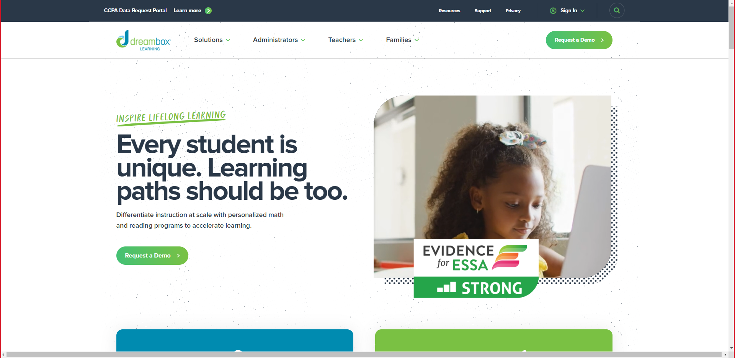

### **2.3.2. ABCmouse**

ABCmouse is an online educational platform that offers a comprehensive curriculum for children aged 2-8 years. The platform uses a combination of interactive games, videos, books, and other activities to support children's learning in a range of subjects, including math, reading, science, social studies, and art.

ABCmouse uses a "step-by-step learning path" approach that guides children through a series of activities that build on each other, with each activity designed to target specific skills and knowledge areas. The platform includes over 9,000 learning activities, with new content added regularly.

One of the unique features of ABCmouse is its use of engaging and interactive animations, videos, and games to support learning. The platform is designed to be fun and engaging for young children, which can help motivate them to learn and stay interested in the content.

ABCmouse also includes tools and features that allow parents and educators to track children's progress and customize their learning experience. For example, parents can set learning goals and monitor their child's progress through the platform's parent dashboard.

Overall, ABCmouse provides a comprehensive and engaging educational experience for young children that can help support their learning and development in a range of subjects. While the platform does not use image detection technology specifically, it does utilize a range of interactive media to support learning, which could be a useful approach for integrating image detection technology into early childhood education.

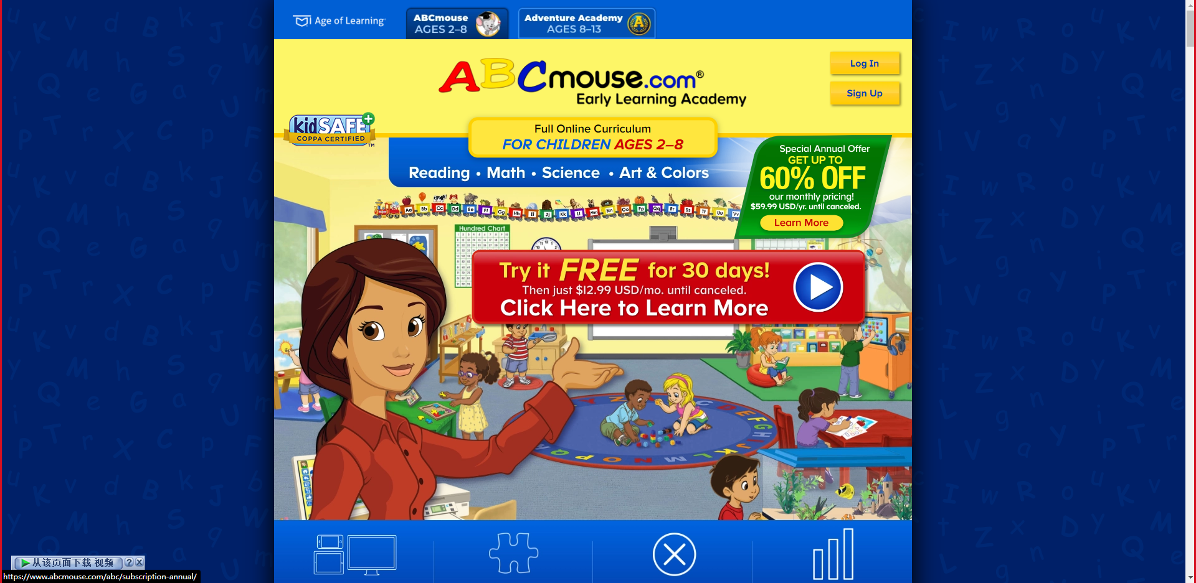

## **2.4. Summary**

For the above literature review, various fields and systems related to image detection and recognition systems were carried out, and many cases were referred to, detailed interpretation and analysis were carried out, and the existing available systems for preschool education were used as objective proof. This proves the feasibility of the project and the revision of the direction of development.

# **3. CHAPTER 3: TECHNICAL RESEARCH**

## **3.1. Programming language chosen**

Both MATLAB and Python are popular programming languages used in scientific and engineering applications, including image detection and processing. MATLAB is a proprietary language developed by MathWorks, while Python is an open-source language with a large and active community.

In terms of image detection and processing, MATLAB has built-in image processing functions and toolboxes that make it easy to perform basic operations, such as filtering and thresholding, on images. However, MATLAB can be expensive to use and requires a license to access all of its features. On the other hand, Python has several image processing libraries, including OpenCV and scikit-image, that are free to use and have a wide range of capabilities. Python also has a larger user community, with a wealth of tutorials and resources available online.

For these reasons, Python is often the preferred language for image detection and processing projects, particularly for those on a tight budget or with limited experience in MATLAB. Python's open-source nature, ease of use, and large community make it a popular choice for research and development in various fields, including preschool mathematics education.

## **3.2. IDE chosen**

There are some advantages of using PyCharm as your IDE for your project on preschool mathematics education based on image detection:

Intuitive Interface: PyCharm has a very user-friendly and intuitive interface that makes it easy to use for beginners and experts alike.

Advanced Features: PyCharm has a lot of advanced features that can help you write better code, such as code completion, code inspection, debugging, and refactoring tools.

Integration with Other Tools: PyCharm integrates with other tools like version control systems, build systems, and testing frameworks, which can help you streamline your workflow.

Large Community: PyCharm has a large and active community of users and developers, which means that you can find a lot of support and resources online.

Python-Specific: PyCharm is specifically designed for Python development, so it has a lot of features that are tailored to the language, such as support for virtual environments, documentation, and code analysis.

Overall, PyCharm is a powerful and user-friendly IDE that can help write better code and streamline the workflow.

## **3.3. libraries chosen / Tools chosen**

There are some popular libraries and tools for your Preschool Mathematics Education Based on Image Detection project using Python:

OpenCV: OpenCV is a popular computer vision library that can be used for image processing, object detection, and tracking. It provides a wide range of functions for image and video analysis.

NumPy: NumPy is a numerical computing library that provides tools for working with arrays and matrices. It can be used for scientific computing, data analysis, and more.

Pandas: Pandas is a library for data manipulation and analysis. It provides tools for reading and writing data in various formats, data cleaning, and data analysis.

Jupyter Notebook: Jupyter Notebook is an interactive computing environment that allows you to create and share documents that contain live code, equations, visualizations, and narrative text. It's a great tool for exploring data and prototyping machine learning models.

Anaconda: Anaconda is a popular data science platform that includes many of the libraries and tools mentioned above. It provides a simple way to manage your Python environment and install new packages.

These are just a few of the many libraries and tools available for this project. The specific libraries and tools that choose will depend on the specific requirements of project.

## **3.4. Operating System chosen**

I will use win10 to develop programs, please give the advantages and reasons.

Windows is the most popular operating system in the world, and most developers are already familiar with it. This makes it easier to set up and use development tools and environments.

## **3.5. Summary**

Choosing the right tool will be very beneficial to the development, which can cause fewer errors in the development, greatly making the development easier and more accurate.

|  |  |
| --- | --- |
| Category | Choice |
| Programming Language | Python 3.0 series |
| IDE | PyCharm |
| Tools/Libraries | Jupyter notebook  OpenCV  Anaconda  Etc. |
| Operating System | Windows 10 or above |

# **4. CHAPTER 4: SYSTEM DEVELOPMENT METHODOLOGY**

## **4.1. System Development Methodology Chosen**

Agile methodology has the following advantages:

It allows for flexibility and adaptability in the development process, which is particularly useful for complex or uncertain projects.

Frequent feedback and iterations help to ensure that the final product meets the needs of the stakeholders.

Collaboration between team members is encouraged, leading to better communication and a greater sense of ownership over the project.

However, Agile methodology also has some disadvantages:

It can be difficult to estimate timelines and budgets accurately, as the development process is more fluid.

Documentation may be lacking, as the emphasis is on working software rather than comprehensive documentation.

It may not be suitable for projects with strict regulatory or compliance requirements.

The Waterfall methodology has the following advantages:

Each phase of the development process is completed before moving on to the next one, which can provide a sense of structure and control.

The emphasis on documentation can help to ensure that the project is well-documented and easier to maintain.

It may be more suitable for projects with strict regulatory or compliance requirements.

However, Waterfall methodology also has some disadvantages:

Changes to the project may be difficult to implement once a phase is completed, which can lead to delays and cost overruns.

Feedback from stakeholders is typically only obtained at the end of each phase, which may result in a product that does not meet their needs.

It may not be suitable for complex or uncertain projects.

For the theme of Preschool Mathematics Education Based on Image Detection, Agile methodology may be more suitable due to its flexibility and adaptability. The development process may involve experimentation and iteration to determine the most effective use of image detection technology in teaching mathematics to preschool children. Frequent feedback and collaboration with educators and parents can also help ensure that the final product meets the needs of its users.

## **4.2. Overview of the diagrams**

For overview of the diagrams, Here are some of the most common ones:

Use Case Diagram, Activity Diagram, Sequence Diagram, Class Diagram, State Diagram. In these diagrams, use case diagrams and activity diagrams are commonly used in agile methodologies:

Use Case Diagram: A use case diagram is a visual representation of the functional requirements of a system. It is used to identify the actors (users) of the system and their interactions with the system.

## **4.3. Overview of how this project will proceed**

Using the Agile methodology, the development process of a Preschool Mathematics Education system based on image detection would be iterative and flexible. The project would start with an initial planning stage where the objectives and requirements of the system are defined. This would be followed by the creation of a prioritized product backlog, which is a list of all the features and functionalities that the system should have.

Next, the project would start working on the first iteration or sprint, which typically lasts two to four weeks. During the sprint, the would develop a subset of the features from the product backlog and create a working prototype of the system. Then review the progress made during the sprint.

Then update the product backlog and plan the next sprint. This process would continue until all the features and functionalities of the system are implemented and the system is ready for release. Throughout the development process, monitor the system frequently to ensure all functions are completed and project requirements are fulfilled according to objectives.

The Agile methodology is particularly suited for the development of the Preschool Mathematics Education system based on image detection because it allows for flexibility and adaptability to changing requirements and feedback from stakeholders. The iterative approach allows for continuous improvement and refinement of the system, which is important in the field of education where the needs and preferences of the users can evolve over time.

# **5. CHAPTER 5: RESEARCH METHODS**

## **5.1: Introduction**

### **5.1.1. The importance and necessity of data collection**

The significance and indispensability of data collection for the development of the project on Preschool Mathematics Education Based on Image Detection cannot be overstated. The data collected from various sources, including questionnaires, will enable the identification of the key challenges and limitations of the current teaching methods in preschool education, the lack of motivation among preschool children in learning mathematics, and their weaknesses in cognitive and problem-solving skills. This data will facilitate the formulation of effective strategies to overcome these challenges and enhance the learning experience of preschool children through the integration of image detection technology. Furthermore, the data collected during the development and testing stages of the project will provide valuable insights into the performance of the system, allowing for continuous improvement and refinement to achieve the desired results. Therefore, the collection and analysis of data are essential components of the project, enabling the successful implementation and realization of its goals.

### **5.1.2. Choice of Data Collection Method**

Two data collection methods that can be used for your topic of Preschool Mathematics Education Based on Image Detection are observation and questionnaire survey.

Observation involves observing and recording behavior or events in a systematic and structured way. This method can be used to collect data on how preschool children engage with mathematics education based on image detection, including their level of interest, engagement, and understanding of the concepts being taught. The advantage of this method is that it provides first-hand, detailed information about the children's behaviors and can provide valuable insights into their learning processes. However, observation can be time-consuming and may require a trained observer who can accurately record and interpret the data.

Questionnaire survey, on the other hand, involves collecting data by asking questions to a group of individuals. This method can be used to collect data on a wide range of topics, such as attitudes, beliefs, and behaviors. For your topic, a questionnaire survey could be designed to gather information on preschool children's engagement with mathematics education based on image detection, including their motivation, understanding, and perception of the effectiveness of the approach. The advantage of this method is that it can be administered to a large number of individuals in a relatively short period of time and can provide quantitative data that can be easily analyzed. However, questionnaire survey may be limited by the quality of the questions asked, as well as the potential for bias or incomplete responses from participants.

Based on the advantages and disadvantages of these two data collection methods, For this project using a questionnaire survey for your project. This method would allow you to gather data on a larger scale and in a more efficient manner, while still providing valuable insights into preschool children's engagement with mathematics education based on image detection. Additionally, by carefully designing the questions and using a representative sample of participants, the potential for bias can be minimized.

## **5.2 Design**

For surveys using questionnaires, the most important thing is the design of the questions in the questionnaires, which will determine the accuracy of data collection and whether it can help the design of the system.

Q1:



Identify the age of the respondents and determine how different age groups view the following questions.

Q2:

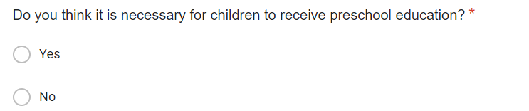

Understand the respondents' views, whether they think preschool education is necessary.

Q3:

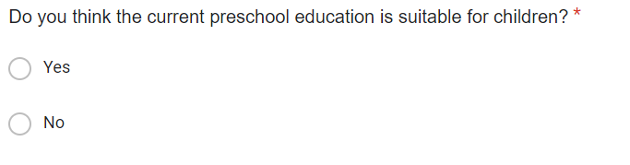

Understand the wishes of the respondents and ask the respondents their views on the current preschool education system

Q4:

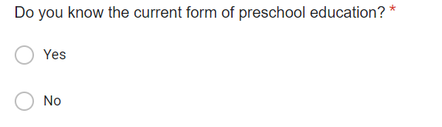

Find out whether respondents understand the current situation to improve the accuracy of the data collected.

Q5:

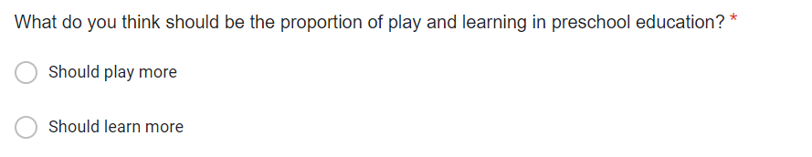

Understand the thoughts of the respondents, whether they think play-based preschool education is more important.

Q4:

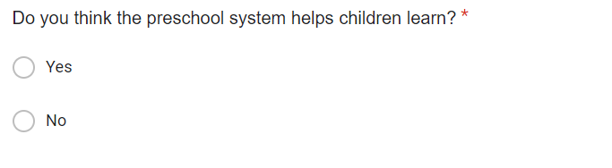

Survey Respondents Think System Use Is Necessary for Preschool Education.

Q6:

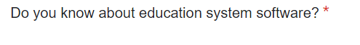

Find out if respondents have used educational software systems

Q7:

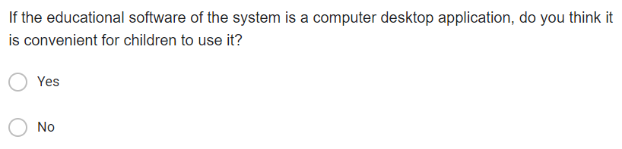

Ask respondents if they are comfortable using desktop software programs

Q8:

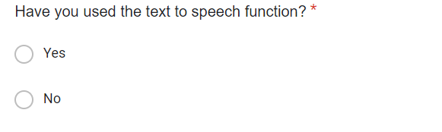

Ask respondents if they have ever used a text-to-speech system

Q9: 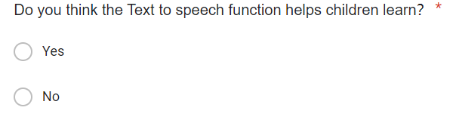

Respondents were asked if they thought text-to-speech would help

Q10:

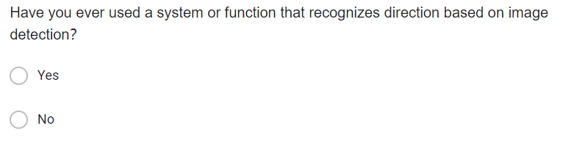

Respondents were asked if they knew about image recognition technology

Q11:

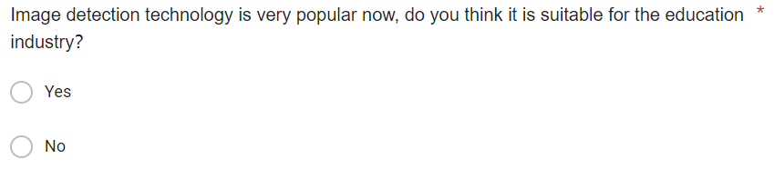  
Respondents were asked if they thought image recognition technology could help children learn

Q12:

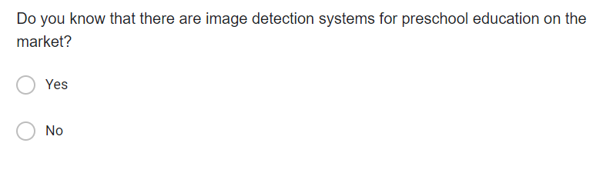

Ask respondents if they are aware of existing image recognition software

Q13:

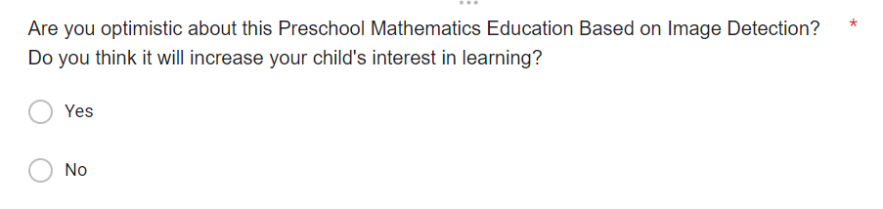

Find out whether the respondents support the project, what is their opinion on the progress of the project.

Q6:



Collect the needs of the interviewees to help plan system functions and improve the humanization of the system.

## **5.2 Summary**

Investigating and studying the project background is an essential step in any project development process. By understanding the project background, developers can gain insights into the target users, their needs, and the goals of the project. This information helps in determining the direction of system development, identifying the key features and functionalities of the system, and designing a user-friendly interface.

Moreover, analyzing the project background can help developers to identify potential problems or limitations of the existing systems, which can help to improve the usability of the system. By understanding the context of the project, developers can make informed decisions about the technology stack, programming languages, and software tools that will be most suitable for the project.

Furthermore, investigating the project background can help in defining the scope of the project, identifying the target audience, and determining the timeline for project development. It can also provide insights into the market demand for similar systems, which can inform the project's prospects and potential for success.

In summary, investigating and studying the project background is crucial for successful project development. It helps developers to understand the project's purpose, target users, and goals, which is essential for designing a system that meets the needs of its users. It also helps to improve the system's usability, determine the direction of system development, and identify potential problems or limitations of the existing systems.

# **6. CHAPTER 6: REQUIREMENTS VALIDATION**

## **6.1 Analysis of Data**

Data analysis is a critical process in any research or project, including Preschool Mathematics Education Based on Image Detection. It involves the process of interpreting and examining data collected through various methods, such as surveys, experiments, and observations, to draw conclusions and make informed decisions.

In the context of Preschool Mathematics Education Based on Image Detection, analyzing data can help in several ways. First, it allows researchers and educators to gain insights into the effectiveness of their teaching methods and the comprehension levels of preschool children. By analyzing the data, educators can identify the areas where students are struggling and adjust their teaching strategies accordingly.

Furthermore, data analysis can help in identifying patterns and trends in the collected data, allowing educators to identify the most effective strategies for improving preschool children's math skills. This knowledge can then be used to develop more targeted and effective educational programs that cater to the needs of each student.

Additionally, data analysis provides a means of evaluating the success of the educational program and measuring the learning outcomes of preschool children. This can help in identifying areas where improvements can be made and providing evidence-based feedback to teachers and policymakers.

In summary, analyzing data is crucial in Preschool Mathematics Education Based on Image Detection, as it provides insights into the effectiveness of teaching methods, identifies patterns and trends, and evaluates the success of the educational program. By understanding these factors, educators and policymakers can make informed decisions that improve the quality of education for preschool children.

### **6.1.1 Analysis of data collected through Questionnaire**

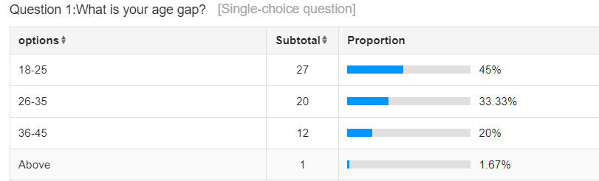

For the first question, it is concluded that the age range of the respondents in the data is mostly 18-25 and 26-35 years old, the grades are relatively young, and they have more views on preschool education

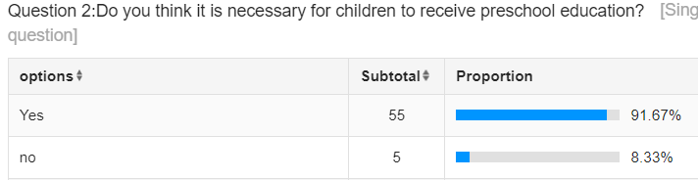

This question is used to investigate the respondents’ views on preschool education. According to the data, the vast majority of respondents believe that preschool education is necessary, which also injects life into the program.

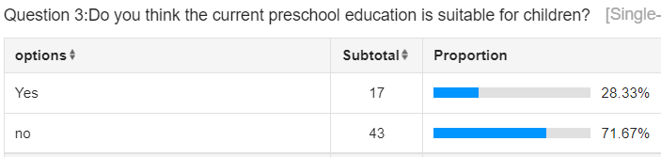

Although most respondents support preschool education, most respondents think that the current preschool education system and system are not suitable

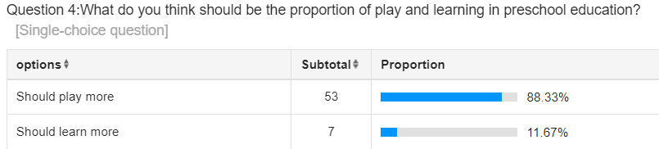

According to the data of this question, the vast majority of respondents believe that the focus should be more on play in preschool education.

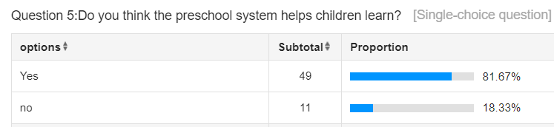

The preschool education system is supported by the vast majority of respondents, who believe that it can help children learn in preschool education

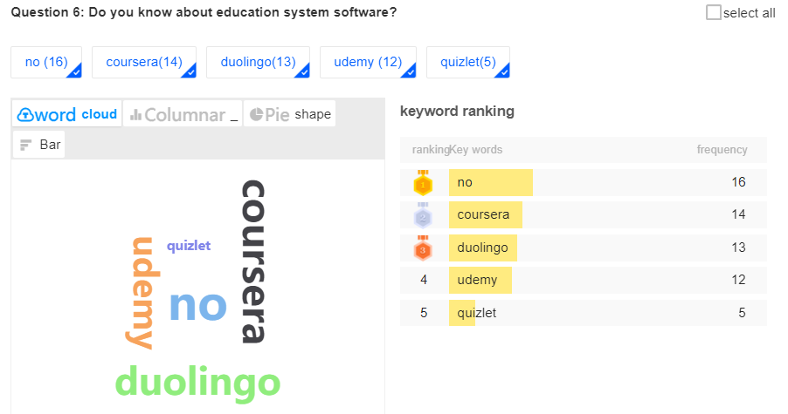

This question collects the education system software that users know. As you can see in the figure, these websites or software are mentioned: coursera(14), duolingo(13), udemy (12), quizlet(5), but some are also affected Interviewers do not understand the existing education system.

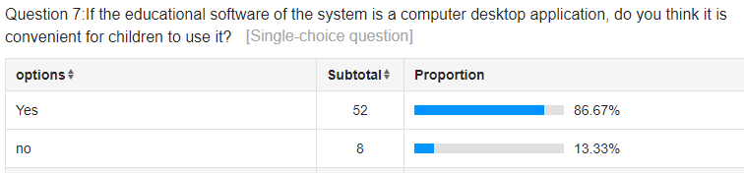

The vast majority of the interviewees did not feel inconvenienced that the project program will use desktop software, so they also confirmed the development method of this system.

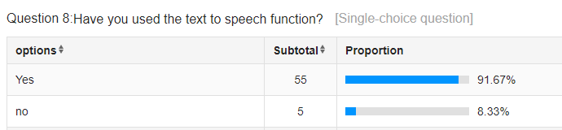

This question is used to understand the universality of the text-to-speech function. It seems that most of the respondents understand the text-to-speech function, that is, some reading functions.

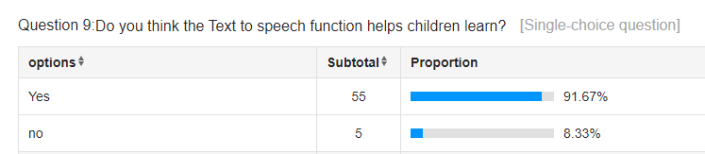

According to the data, it can be seen that most people think that for preschool education, the text-to-speech function must be added to the software, so for the system functions, it is also confirmed that the text-to-speech function needs to be added.

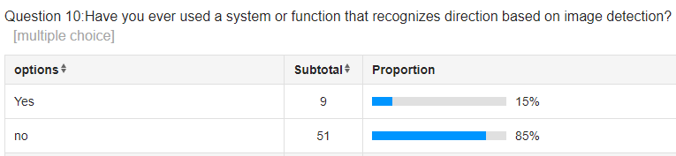

Understand whether image detection is generally recognized in the daily life of the crowd, most users do not seem to directly use image detection technology in their lives, which also proves that image detection technology has a very broad prospect.

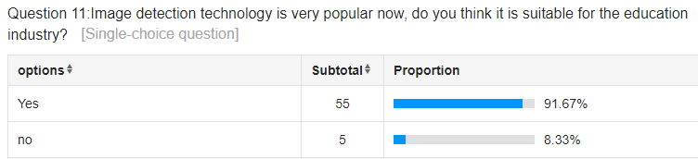

The preschool education of image detection technology users is supported by most people, and it also adds confidence to the progress of this project.

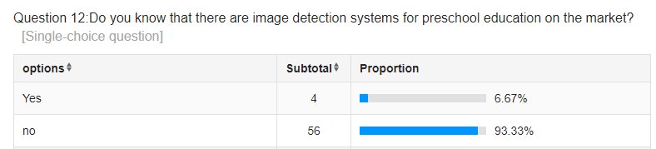

This problem understands that image detection technology for preschool education is not widely used, and it also proves that this project has a promising future and can benefit from image detection technology to help preschool education.

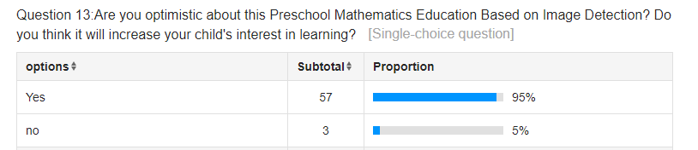

Most of the interviewees maintain a supportive attitude towards this project, agreeing that this project will bring help to the field of preschool education.

## **6.2 Summary**

The results of the survey have shown that the two main functions of image detection and text-to-speech will be valuable for the development of the Preschool Mathematics Education Based on Image Detection project.

Image detection will play a crucial role in recognizing and analyzing visual stimuli in order to facilitate the learning of mathematical concepts for preschool children. Through the use of image detection, the system will be able to identify and classify different shapes, colors, and numerical values, which can then be used to generate interactive and engaging learning activities. This function will enable children to learn and understand mathematical concepts in a more intuitive and interactive manner.

On the other hand, the text-to-speech function will enable the system to convert written text into speech, making it easier for preschool children to comprehend and interact with the content. This feature will allow the system to provide real-time feedback and guidance to children as they engage in learning activities. The ability to convert written text into speech will also make the system more accessible to children with visual impairments or those who may struggle with reading.

In conclusion, the value of image detection and text-to-speech functions cannot be overstated in the development of the Preschool Mathematics Education Based on Image Detection project. These features will help to create a more engaging and interactive learning environment for preschool children and facilitate their understanding and mastery of mathematical concepts.

# **7. CHAPTER 7: SYSTEM ARCHITECTURE**

## **7.1. Introduction**

Preschool Mathematics Education Based on Image Detection, this system is committed to providing a learning platform for numbers, symbols and arithmetic calculations for preschool children or children at the mathematics enlightenment stage in the field of preschool education. It uses various functions to let children understand numbers and basic operation rules. At present, there are many educational platforms for preschool children, but it is still a relatively new idea to use image detection in this field. The foundation of the program is accuracy. This model uses handwritten numbers and common stationery items for training to meet the accuracy requirements for target detection. The entire project can be deployed locally and can be run without internet connection, so that many children can use the program to learn anytime and anywhere without being bound by the network, which is more convenient. Moreover, the program has a perfect interface, and children without any experience can easily operate and use it after simple learning.

## **7.2. System Design**

### **7.2.1. Function Design**

In this part, the functions of the program will be planned, and the idea of completing the answering program will be fully displayed in this part. All the functions of this program are as concise as possible but not crude, because it is aimed at children and users need to learn how to use the program easily. The functions and implementation ideas included in the program are explained as follows:

Items and their quantity detection: In this function, basic stationery objects will be identified. Recognizable stationery objects include stationery that children will use rulers, pencils, erasers, pencil sharpeners, and display the total number of detected objects.

This function exists for fun. Use interesting functions to attract children's interest and stimulate children's interest in numbers. For example, if a child takes out five pencils, the test result will show that there are five pencils, and the number is five. Children can understand the meaning of the number 5 simply and directly. If the child takes out a pencil sharpener and two erasers, the program will display the pencil sharpener and erasers. The total number is three. Children's interest in learning and avoid resistance to mathematics learning.

Handwritten number detection: In this function, handwritten numbers will be recognized, and natural numbers from 0 to 9 can be recognized. After the number is detected, the number that detected by system will show, and the recognized number will be read aloud. For example, the handwritten number 6, if the system recognizes Number 6, the number 6 will be displayed on the screen and framed out, and then the number 6 will be read aloud, so that the user can hear what the number is.

This function not only provides fun, but also allows children to learn basic digital writing and pronunciation, allowing children to do it themselves, and more clearly understand the writing and pronunciation of basic numbers from 0 to 9, thereby enlightening children's mathematical thinking, and You can also standardize the writing of numbers and gradually accept the fun brought by numbers.

Arithmetic symbol detection: This function will recognize handwritten arithmetic symbols, and can recognize: "+", "-", "*", "/", "=" These basic arithmetic symbols, when the program detects the arithmetic symbols handwritten by the user, the arithmetic symbols detected by the system will be selected and displayed, and the detected symbols will be read aloud. For example, if a "+" written by the user is detected, the "+" sign will be displayed on the screen and read aloud.

This function is the same as handwritten number detection. While avoiding boring learning, it can also let children learn to understand various basic characters, let children learn handwritten symbols, let children know basic characters, and standardize writing.

Calculated formula detection: This function can detect the user's handwritten formula, and then calculate the result of the user's handwritten formula, and then display the user's written formula and the calculation result on the screen. For example, if the user writes 5+3, the program will detect and display "5", "+", "3", calculate the result and then display "=", and "8", and will read the entire calculation formula aloud.

Based on the previous functions, this function is more for learning calculation knowledge and less for entertainment. When children want to understand the result of a calculation formula, they can use the program to recognize the calculation formula written by the user and get the correct result, so that children Learning the calculation results of various calculation formulas paves the way for children to learn mathematics in the future, so that children can experience the fun of mathematics.

Calculation result detection: This function is different from the previous function. It will provide random formula generation, which can generate addition, subtraction, multiplication, and division within 10, let the user write the formula and answer by hand, and then detect the complete formula written by the user and display it Detected complete formula, and prompts the answer of the formula and whether the calculation is correct. For example, the user clicks on the random generation formula, and the computer generates "3+5", and the user needs to write down "3+5=8" by hand, and then use the program to detect it. When the program detects the formula "3+5=8", it will display that the calculation is correct.

This feature goes a step further in terms of difficulty, because users not only need to understand basic calculations, but also be able to correctly write all the numbers and symbols in the calculations by hand.

With this feature, users can constantly challenge themselves and improve their numeracy and handwriting accuracy.

### **7.2.2. Use Case Diagram**

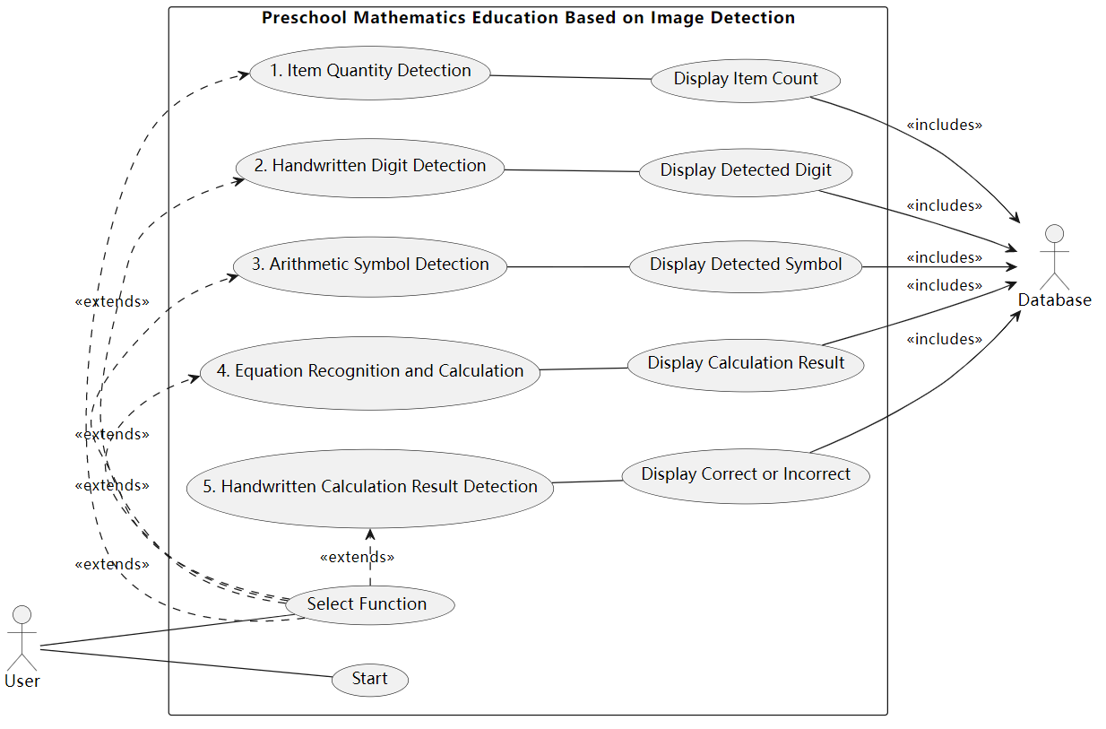

### **7.2.3. Activity Diagram**

Function 1: Item Quantity Detection

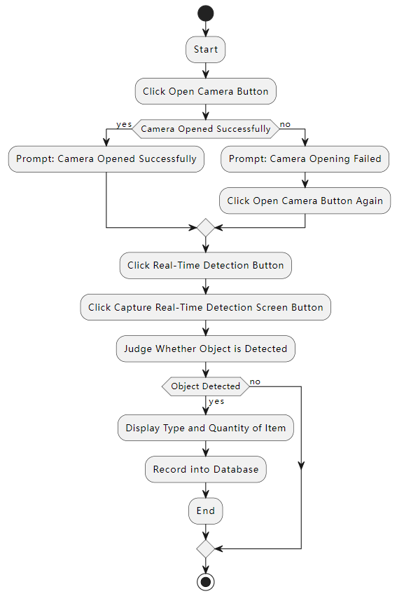

Function 2: Handwritten Digit Detection

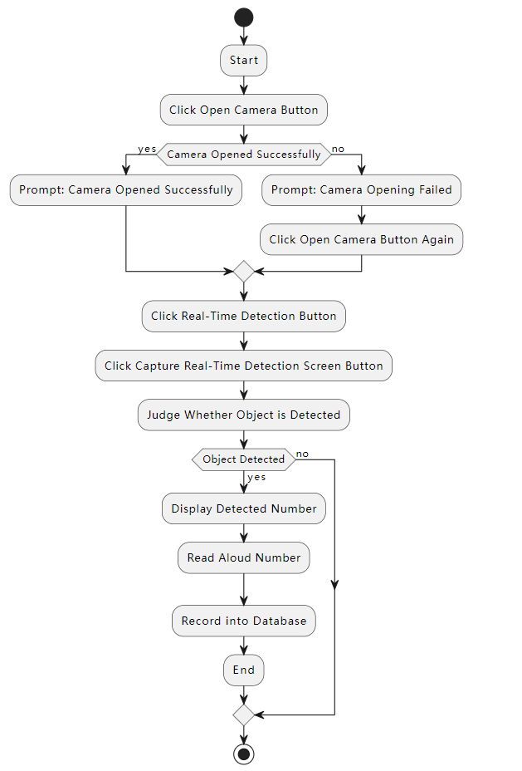

Function 3: Arithmetic Symbol Detection

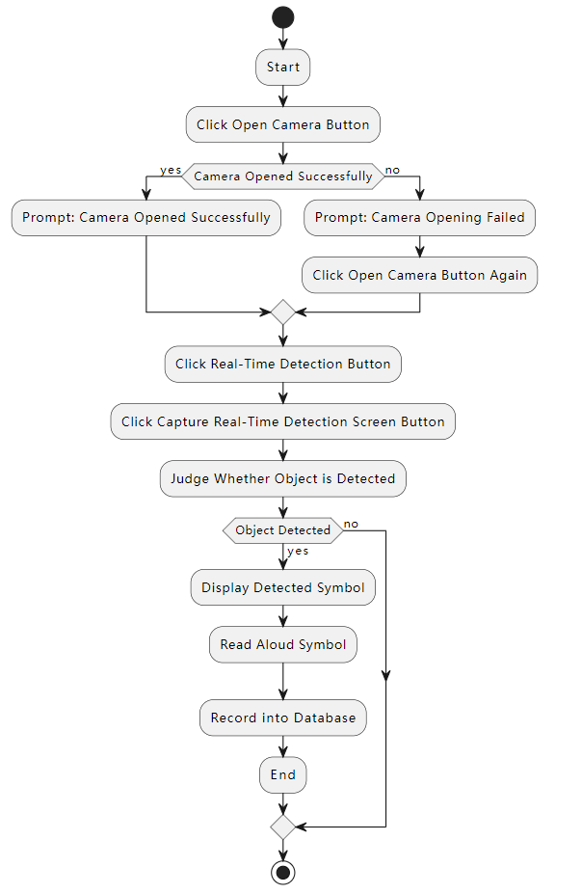

Function 4: Equation Recognition and Calculation

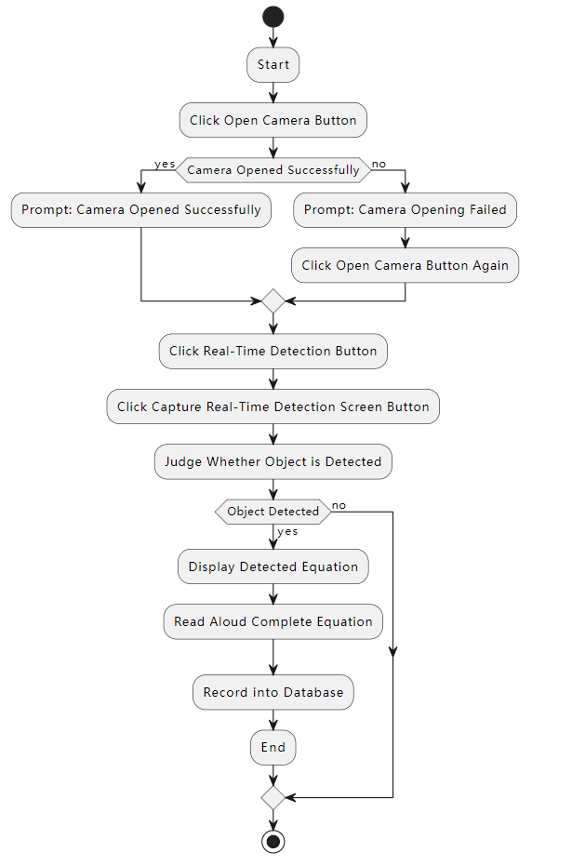

Function 5: Handwritten Calculation Result Detection

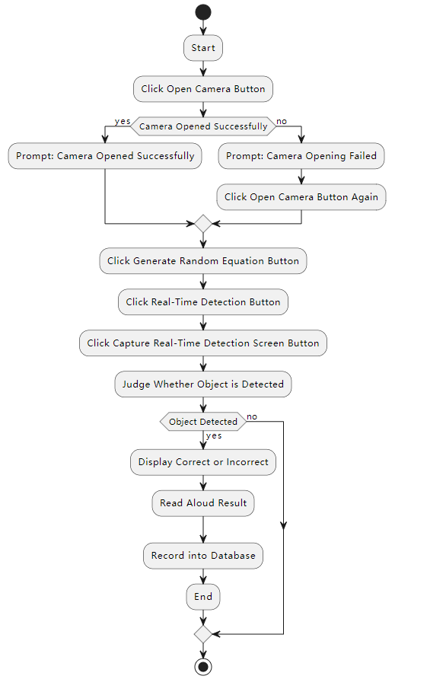

## **7.3. Model Training**

In the image detection program, the most important step is the training of the model. The accuracy of the model training will directly affect the performance of the program, so the selection of the data set is also very important.

### **7.3.1. Data collection**

For the realization of project functions, the required data set needs two parts. First, the stationery data set is required to recognize objects. For handwritten numbers, symbols, and calculation formulas, the handwritten content needs to be recognized as a data set.

For the stationery dataset, a large number of resources can be collected on the Internet. For the accuracy of the project, I selected a labeled dataset uploaded by a user nicknamed "University work" on the Rob flow website as the dataset for stationery recognition. The data set contains 621 pictures, thanks to "University work" for uploading the data set.

In addition, for the data set of handwriting recognition, it is quite complicated and takes a lot of time, and it is necessary to handwrite numbers, symbols, and calculations one by one. And it needs to be marked one by one, but in the end, about 200 pictures containing handwritten Arabic numerals from 0-9, and "+", "-", "*", "/", "=" and these symbols were obtained.

### **7.3.2. Data preprocessing**

For image processing, I have written different Python codes for image specifications and image names for some processing. There are also some manual steps involved. These steps will be explained step by step.

For the pictures taken, I first processed the specifications with Python code, so that the pixel size of each picture is 640*640, which is the best specification for training, and exported after processing, to ensure that the size of the pictures is consistent, which is convenient for subsequent training.

Although there are about two hundred images of the same specification, their names are confusing. I use Python code to rename the images in the folder and arrange them in ascending order starting from 0. After the operation, the files in the folder are arranged in neat ascending order., which is convenient for subsequent operations.

Check the images in the folder and use image rotation to make all images in the same direction, to avoid using wrong images when training the model and affecting the accuracy.

Then, for the data set processed by the specifications, some image enhancement operations can be performed, and the samples are expanded.

### **7.3.3. Data Partitioning**

The main reason for dividing the dataset into training, validation and test sets is to evaluate and improve the performance of the trained model and to improve the generalization ability of the model on new data.

For common training sets, the ratio is roughly training set: validation set: test set ratio is 70%: 15%: 15%, and separate the data sets. When dividing the data sets, ensure that there is no overlap between the data sets. Each sample can only exist in one dataset to avoid data leakage issues.

### **7.3.4. Model Selection**

For the model selection of this project, I chose YOLO v5. For this model, it has the following advantages:

Real-time performance: Using a lightweight neural network structure, the YOLO ⁠ V5 algorithm can quickly and accurately detect targets. This makes it excellent in real-time applications such as ⁠ video analytics, autonomous driving, and real-time surveillance. ​

Accuracy: YOLO V5 has high ⁠ accuracy in target detection tasks. It makes lots of cool changes ⁠ to be even better! It uses an improved network that ⁠ finds more important details. It also tests things in different ways ⁠ and makes the data even cooler. All these changes make ⁠ it much stronger! ‌

Simple and efficient: The simplicity of the network design in YOLO ⁠ V5 makes it easy to comprehend and execute. It uses Feature Pyramid Network and feature fusion technology, which can detect ⁠ targets at different scales, thereby improving the global consistency of detection. ⁠

Open-source community support: YOLO V5 is open ⁠ source with active community support and contributions. This means you can get the newest updates, model weights, and pretrained models from ⁠ the community, as well as receive assistance with solving problems and receiving support. ‍

Multi-platform support: You Only Live Once (YOLO) V5 can be ⁠ used on different platforms like CPU and GPU devices. It can also be optimized for embedded ⁠ devices to suit different application situations. ​

### **7.3.5. Model Training**

The initial requirement in training the YOLO v5 model is ⁠ to have a prepared dataset of labeled images. The associated object label of each image contains ⁠ the bounding box coordinates and class label. Then, follow the steps ⁠ below for model training: ⁠

At the initial stage, fetch the image and ⁠ label datasets and conduct the requisite preprocessing operations. Among these operations are modifying the image size to meet the dimensions specified by the model ⁠ and standardizing pixel values to ensure uniformity in range and distribution of input images.

Afterwards, proceed to define and ⁠ initialize the YOLO v5 model. This encompasses the tasks of determining a network architecture, ⁠ setting hyperparameters, and loading pretrained weights if needed. Following these initialization steps will guarantee the availability ⁠ of a model suitable for training.

During every training iteration, the model is fed ⁠ with image data for forward propagation. The model will provide projections, which encompass the ⁠ coordinates and probabilities of object bounding boxes. Afterwards, employ a loss function to compute the ⁠ disparity between the forecast and the target.

The backpropagation algorithm is applied to the ⁠ loss function to compute the gradient. The gradients point out which way should alter the ⁠ model parameters in order to minimize the loss function. Afterwards, an optimization algorithm such as stochastic gradient descent is utilized ⁠ to adjust the model's parameters by considering the gradient information. Through this method, the model will progressively adapt its ⁠ parameters to suit the training data more closely.

The process of training usually needs many iterations (epochs) of ⁠ training to slowly make the model perform better. For every iteration, we employ various batch sizes ⁠ of image data for training the model. Larger batch sizes can improve training speed, ⁠ but also require more memory. Smaller batch sizes can provide more stable gradient estimates but may lead to a slower training process.

Opting for the appropriate hyperparameters is a ⁠ vital decision in model training. A typical approach for selecting a learning ⁠ rate involves gradually decreasing it. This begins with a higher initial learning rate and then ⁠ progressively lowering it to enhance the model's convergence. You need to think about training speed and memory ⁠ requirements when deciding on the batch size.

Through the mentioned procedures, can progressively educate the YOLO v5 model to ⁠ have a stronger ability to recognize objects and enhance its overall performance. but also generalizing over other similar inputs.

### **7.3.6. Training Result**

After the model training, the recognition accuracy rate of more than 90% has been achieved at one time, and the recognition results for most handwritten numbers and basic stationery are quite accurate. So far, the basics of the program have been completed, and the model can be deployed, and the program produced.

## **7.4. Database design**

This program chooses opting for MySQL as ⁠ the project's database of the project. A relational database management system is MySQL Its notable ⁠ features include stability, scalability, and comprehensive security controls. The presence of these features MySQL ideal for storing, ⁠ processing, and retrieving large amounts of data. ​

The primary utilization of this program's database revolves ⁠ around monitoring and documenting the learner's progress. It accurately measures their learning level per session and ⁠ evaluates their stages based on record precision. The program's personalized learning experience is enhanced by ⁠ this design and improve children's learning efficiency. ​

The database ERD is designed as follows:

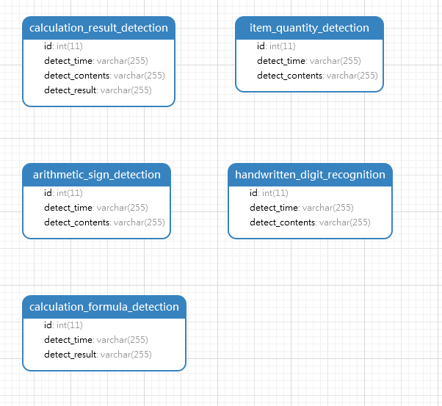

The figure illustrates that a total of five tables exist ⁠ within the database which correspond to five functions. Id, time and detected content are recorded by this program in the first three tables, ⁠ Furthermore, in the case of these three tables specifically record items, numbers and symbols. This program not only logs the id, time and detected formula for the ⁠ fourth function but also includes the calculation result of the formula. Furthermore, concerning the fifth function, moreover, this program captures the id, time, detected ⁠ formula and result, and furthermore shows if it is accurate or not. ​

This database design permits the program to save and ⁠ access data systematically, consequently boosting data processing efficiency. Each table has its specific purpose, improving the ⁠ clearness and tidiness of data arrangement. Furthermore, via documenting the comprehensive information of every individual study, the application can enhance its comprehension ⁠ of the user's learning advancement and influence, thereby delivering a more tailored learning encounter. This kind of database design supplies potent back-end assistance for the endeavor for this ⁠ program's purposes, enabling it to this program can more efficiently cater to user requirements. ⁠

An additional upside when utilizing MySQL, one of ⁠ its advantages is its open-source nature. This implies it boasts a substantial community of ⁠ developers supplying abundant resources and support. Furthermore, MySQL also exhibits exceptional performance and speed, and possesses the capability to manage numerous simultaneous connections, ⁠ which is crucial for this program that requires managing a significant volume of user requests. In conclusion, the scalability of MySQL plays a significant role, enabling it ⁠ to handle growing data requirements while the application progresses and advances.

## **7.5. UI Design**

In the user interface part, five pages are required, which are object quantity detection, handwritten number detection, arithmetic symbol detection, calculation formula detection, and calculation result detection.

On each page, there are some same buttons, such as upload image detection button, open camera button, real-time detection button, interception content detection button, and end detection button. And each program has two display boxes, which are used to display the real-time monitoring content and the captured image content respectively.

In addition to these basic buttons and controls, tables are needed to display content in object recognition detection, calculation formula detection, and calculation result detection. In the calculation result detection function, four additional buttons are required to provide function buttons for randomly generating calculation formulas.

Function 1: Item Quantity Detection

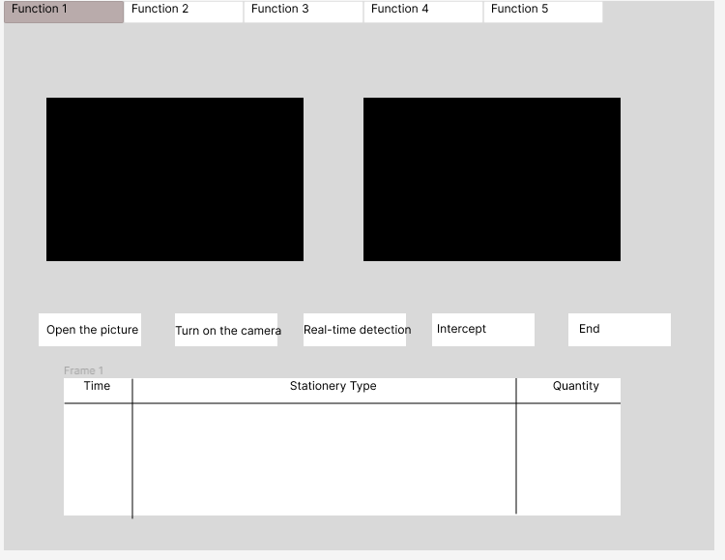

Function 2: Handwritten Digit Detection

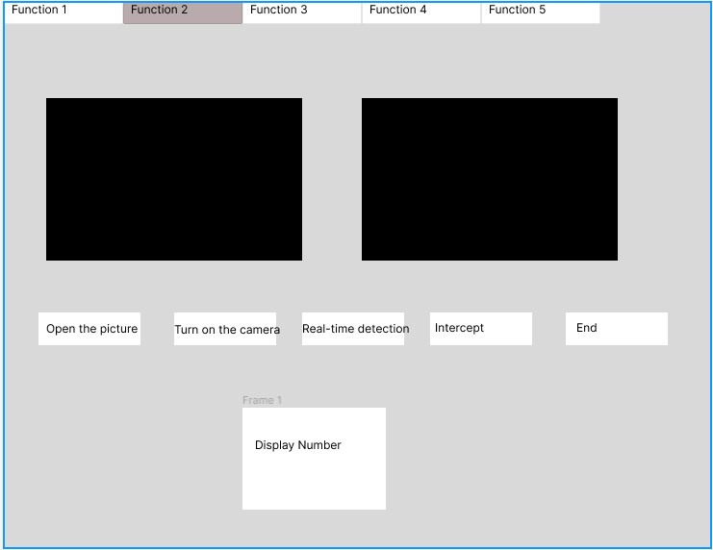

Function 3: Arithmetic Symbol Detection

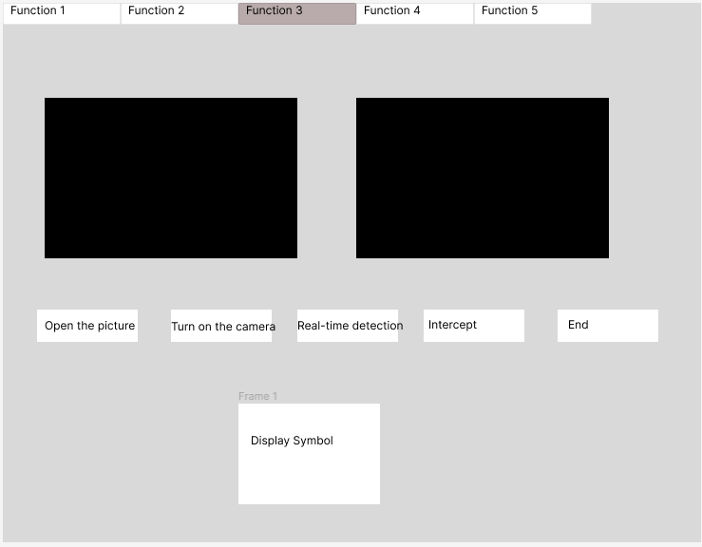

Function 4: Equation Recognition and Calculation

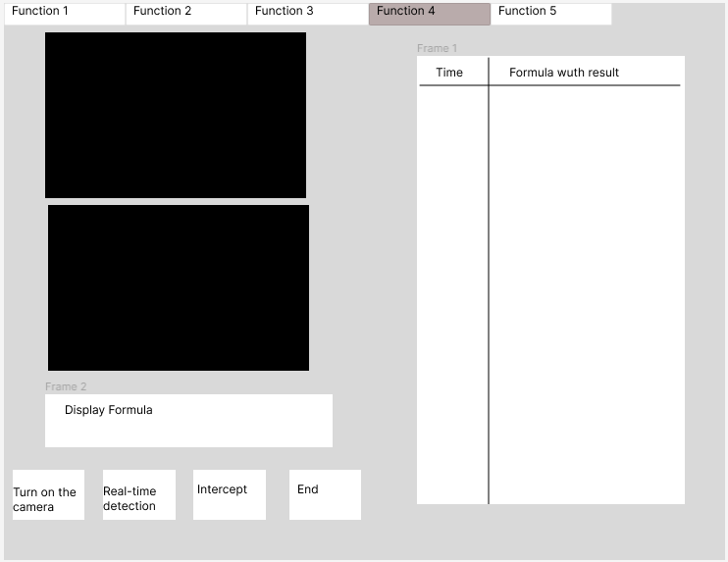

Function 5: Handwritten Calculation Result Detection

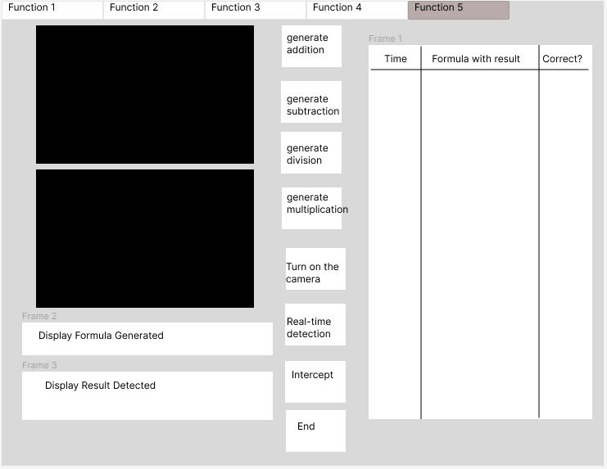

# **8. CHAPTER 8: Project Plan**

## **8.1 Details of the release plan**

### **8.1.1 Version 1.0 of your project title**

The first version will be launched on July 10 for user testing and feedback. This version will include functions other than database and voice broadcast for testing.

### **8.1.2 Version 2.0 of your project title**

The second version will be launched on July 20th for user testing and feedback. This version will fully contain all functions, and the overall user testing will be conducted recently to make final revisions.

## **8.2. Function Useable Test**

|  |  |  |  |  |
| --- | --- | --- | --- | --- |
| ID | Test Case | Expected Outcome | Actual Outcome | Pass/Fail |
|  | Detect Model Accuracy Tests - Stationery | It has high accuracy for the detection of a single stationery and can detect object categories |  |  |
|  | Detect Model Accuracy Tests - Symbols | It has high accuracy for the detection of a single symbol and can detect the type of symbol |  |  |
|  | Detect Model Accuracy Tests - Numeric | It has high accuracy for the detection of a single number and can detect the size of the number |  |  |
|  | Detect Model Accuracy Tests - Formula | The detection of the entire formula has high accuracy, and the formula can be detected, so that the calculation |  |  |
|  | Open camera function test | The camera is successfully opened, and a pop-up window will notify that the opening is successful. If it is not connected, it will display that the camera is not detected, and the opening fails |  |  |
|  | Real-time detection function test | It can display the camera screen, and detect the content in the image in real time, and accurately select and mark all stationery and calculation formulas |  |  |
|  | Intercept real-time detection screen function test | Capture the content of the camera and display it on the right side of the real-time monitoring window, select the detected item, and if it is a single number or character, the corresponding voice will be broadcast |  |  |
|  | Upload picture function test | After clicking, a file selection pops up to select a computer file for detection. Just like capturing the content of the camera, select the detected item, and if it is a single number or character, the corresponding voice will be broadcast |  |  |
|  | System Computing Ability Test | Test the computing power of the system, can calculate the detected formula and get the correct result |  |  |
|  | Functional Test of Randomly Generated Algorithms | Randomly generate addition, subtraction, multiplication and division within ten |  |  |
|  | Voice broadcast function test | After detecting a numeric character or calculating a formula, the corresponding voice will be broadcast, and if it is a formula, the entire formula will be read aloud |  |  |
|  | End detection function test | After the end of the detection click, stop using the camera and release the camera |  |  |
|  | Database | Corresponding information will be stored after detection |  |  |

## **8.3. Test plan for User Acceptance Testing**

Strategy Description:

A user intention survey is part of the strategy, when users actively ⁠ participate in using the application ...and provide input on various aspects. The format of the survey to address every important function ⁠ and factors affecting user interaction of the software. Each area requires users to indicate their level of satisfaction by rating their experience., supplying users with a numeric ⁠ measure for evaluating their satisfaction. Moreover, they are pushed to offer qualitative input, presenting observations about potential developments. ​

Benefits of this Strategy:

1. Comprehensive Evaluation: Applying this strategy facilitates ⁠ a complete analysis of the application. It addresses all important elements, from functionality to ⁠ user interface, accuracy, and overall user experience. ​

2. User-Centered: The main emphasis of the strategy lies in putting the needs and preferences of ⁠ end users at the center., prioritizing both user experience and satisfaction as key objectives. By doing so satisfying the requirements ⁠ and satisfaction of users. ‌

3. Identifies Areas for Improvement: The act of gathering user feedback ⁠ facilitates the recognition of areas that can be developed. This can guide future development efforts, Resources should be directed ⁠ towards areas that will most enhance user satisfaction. ‌

4. Increases User Satisfaction: By actively involving users in the testing process and ⁠ incorporating their feedback, this method can contribute to boosting user satisfaction. It is probable that users will value a customized ⁠ app that meets their requirements and choices. ‌

5. Risk Mitigation: Carrying Out UAT can Conducting User Acceptance Testing aids in ⁠ recognizing any challenges or difficulties before officially releasing the application. can help identify any issues or problems ⁠ before the application is fully launched. This can mitigate risks and stop potential negative effects on ⁠ user contentment or the image of the brand. ​

|  |  |  |
| --- | --- | --- |
| **Test Case** | **Answer/ Evaluate** | **Rating** |
| **Functional experience**  -Whether the function is comprehensive  -Whether such a functional design can meet the learning needs of children |  |  |
| **User interface experience**  - Interface look and feel  - Does the interface feel stuck? |  |  |
| **Accuracy**  - Whether the detection is accurate  - Is there any misidentification |  |  |
| **Voice broadcast**  -Whether the pronunciation is clear and accurate  - is there more fun |  |  |
| **Ease of use**  - Is it easy to use  -Is it difficult to use |  |  |
| **Overall feeling**  -Whether it can help children learn mathematics  - Is it novel and interesting enough? |  |  |

# **9. CHAPTER 9: Implementation**

In this part, the complete program architecture will be introduced in detail, and the UI, program completion and code will be explained step by step.

## **9.1 UI Design**

The system has undergone rigorous adjustments and optimizations in order to achieve ⁠ accurate object identification and cataloging, including challenging or crowded surroundings. This high level of accuracy Not just ⁠ improving the overall user experience. Moreover, it confirms that the information provided ⁠ to users is dependable and trustworthy. ⁠

**Item quantity detection function interface**

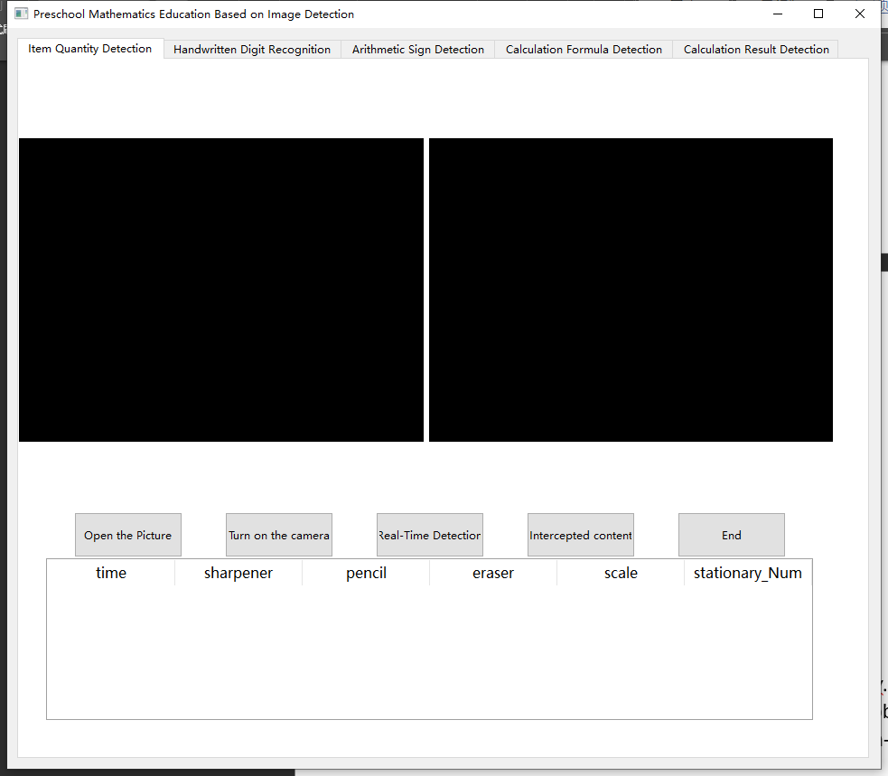

This interface contains basic buttons and provides a list for the user to see the detection time, the type of detected items, and the total quantity. The large windows above are the real-time detection content and the preview of the intercepted content respectively.

Use Effect:

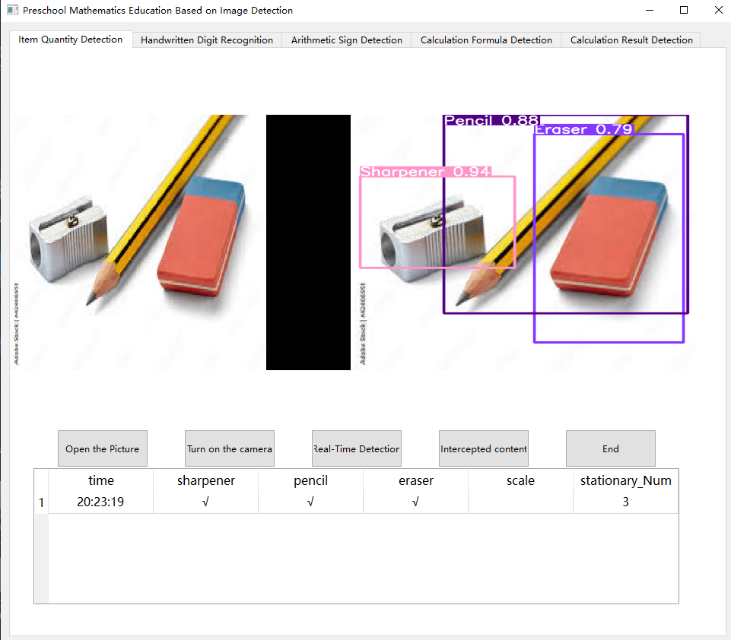

The main point of interaction for the user is through ⁠ this interface when utilizing the object detection function. Upon initiating the detection process by the user, the system ⁠ carefully examines and recognizes items in the view. Every identified item is thoroughly recorded within a table ⁠ that appears beneath the primary user interface. The provided table presents a transparent and ⁠ brief outline of the recognized items. It allows users to easily comprehend the ⁠ results of the detection process. ​

In addition to showing each item separately, moreover, it has the capability ⁠ to determine and exhibit the combined quantity of detected objects. Offering users, a rapid and straightforward point of reference if they ⁠ require information on the overall object count within the frame. Saving them the time and effort ⁠ involved in manual counting. ​

**Handwritten digit detection**

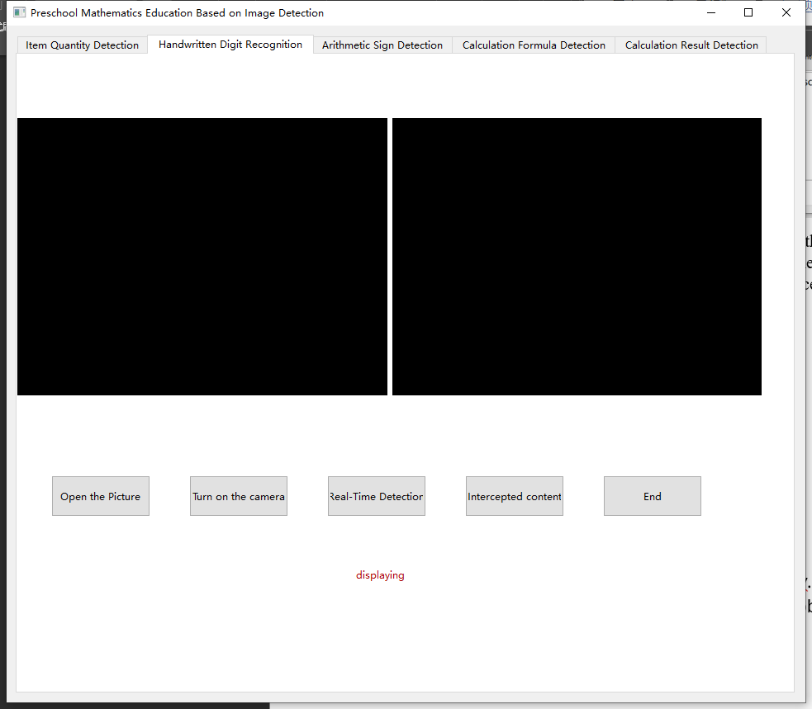

This interface contains basic buttons, and the large windows above are real-time detection content and intercepted content preview. And the detected number will be displayed in the control below.

Use Effect:

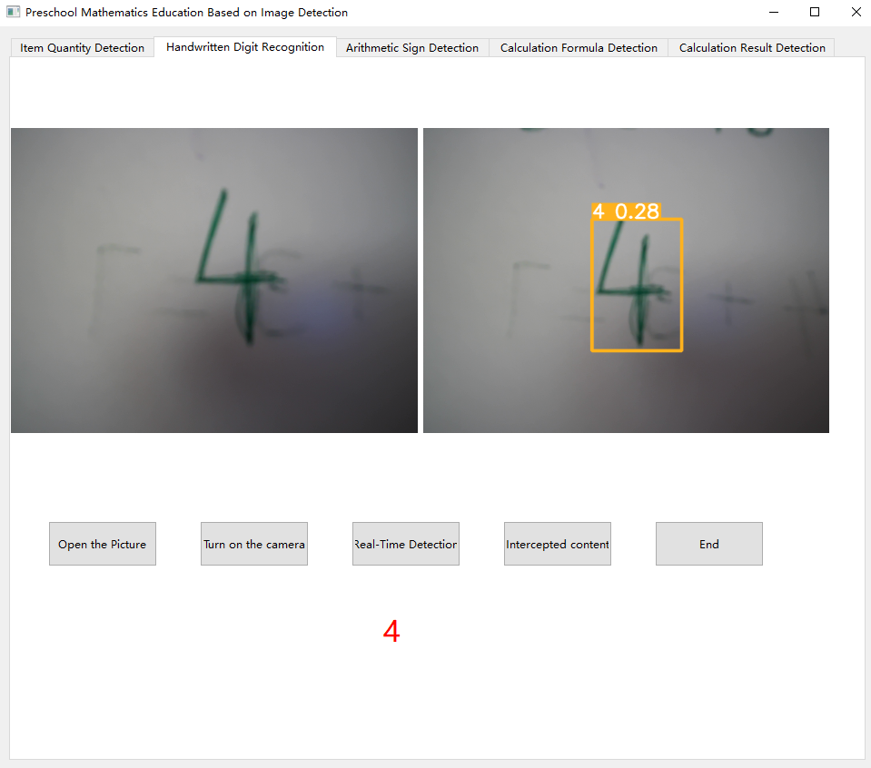

Similar to the user interface of the first function, but when a single number is detected, it will read the broadcast and display the number.

**Arithmetic sign detection**

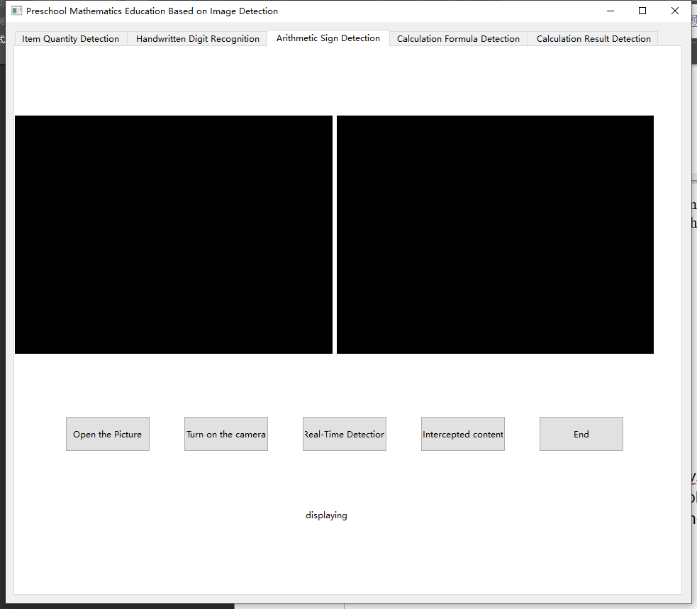

This interface contains basic buttons, and the large windows above are real-time detection content and intercepted content preview. As with handwritten digit feature detection, the detected number will be displayed in the control below.

Use Effect:

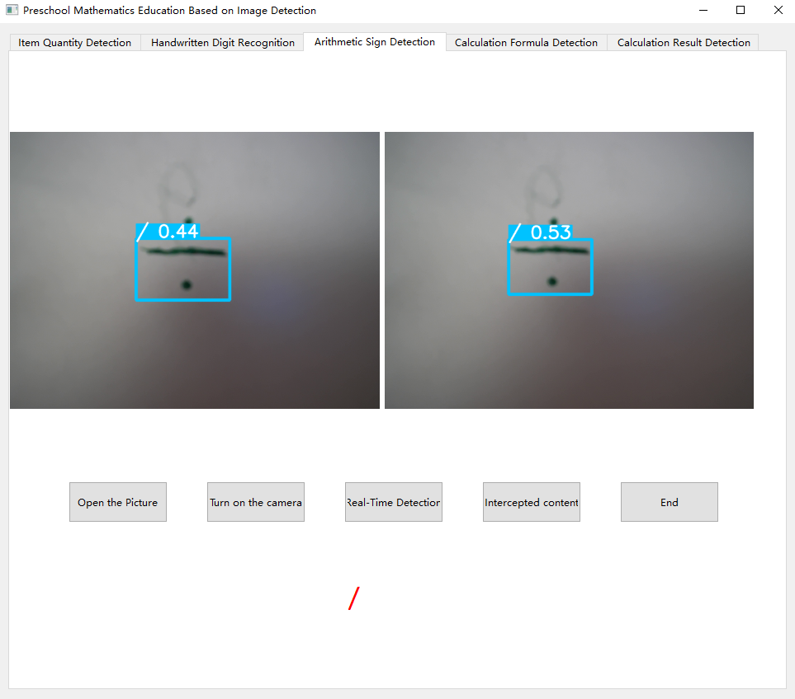

Similar to the user interface of the first function, but when a single symbol is detected, the broadcast will be read and the symbol will be displayed.

**Calculation Algorithm Detection**

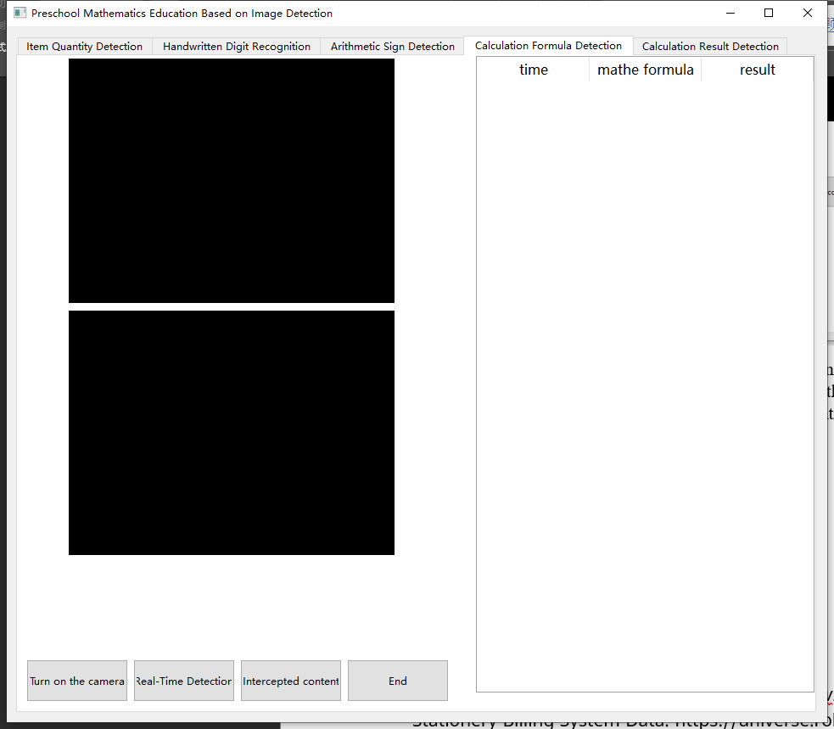

In this interface, compared with the previous functions, there are major changes. In addition to the basic buttons, there is also a large list that will display the detection time, the calculation formula written by the user, and the calculated result.

Use Effect:

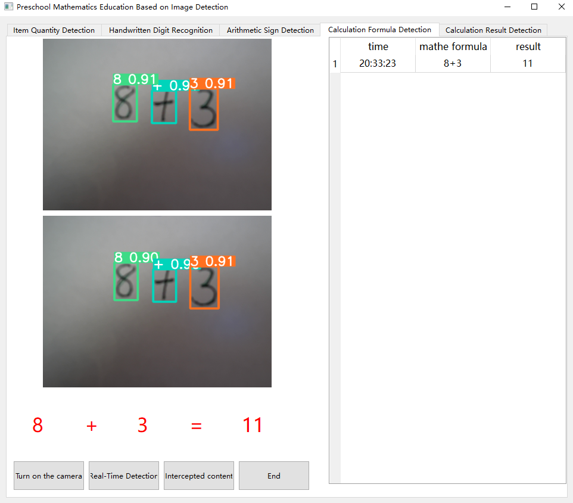

When the user writes out the formula, as shown in the figure "8+3", the program will display 8+3=11 and read the complete formula aloud. And the table on the right will show the calculation records.

**Calculation result detection**

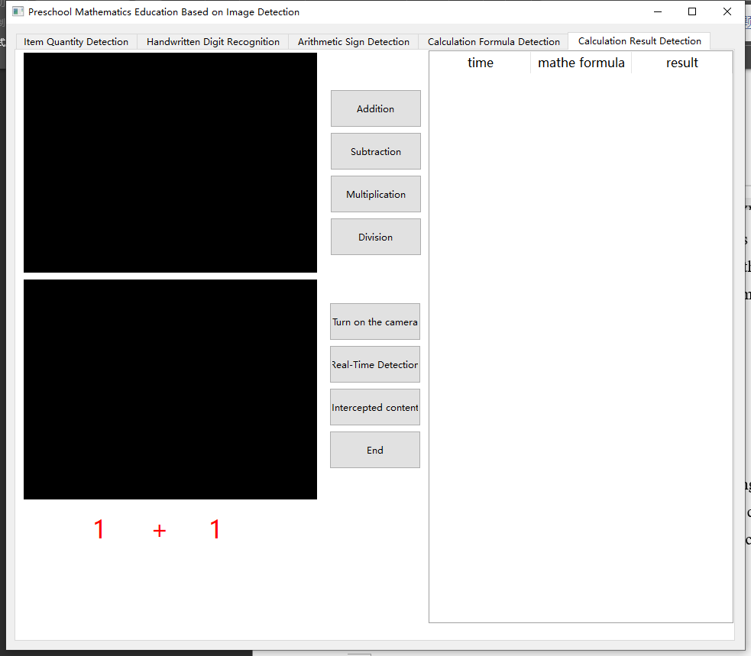

This function includes four additional buttons for generating calculations of addition, subtraction, multiplication, and division, but the generated calculations are all within 10, and the list on the left shows the detection time, the calculations written by the user, and whether the results are correct.

Use Effect:

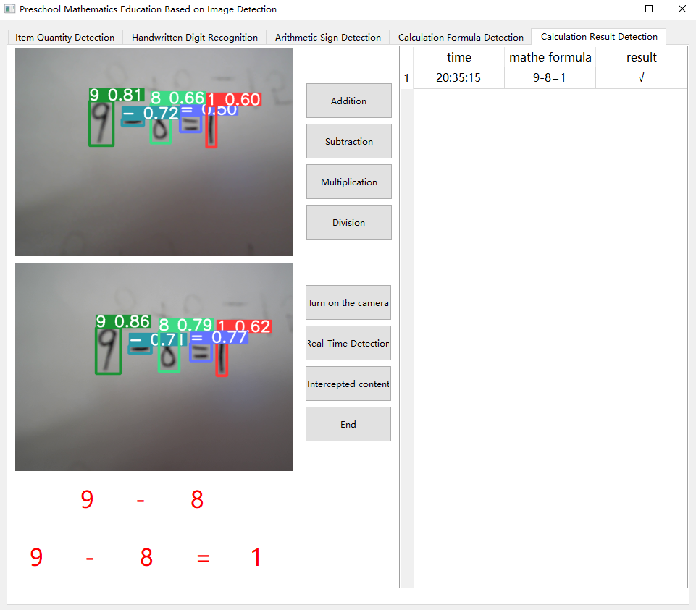

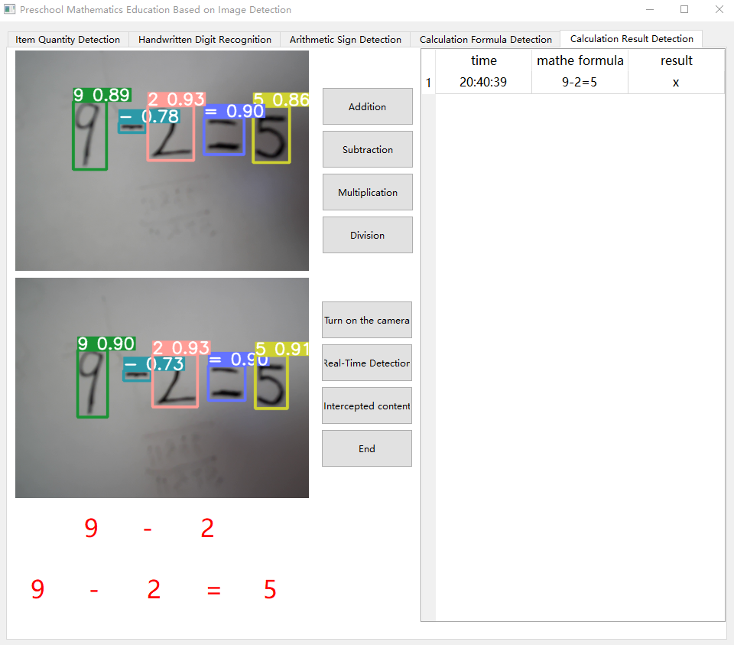

With this function, when the user clicks to generate a formula, the generated formula will be displayed first, so that the user can copy down the formula and write the result, and then perform a test. When the calculation result is correct, it will be displayed on the right table and read aloud. If the result is wrong, it will not be read aloud, and the right table will display the error.

## **9.2 Sample Codes**

### **9.2.1 Libraries**

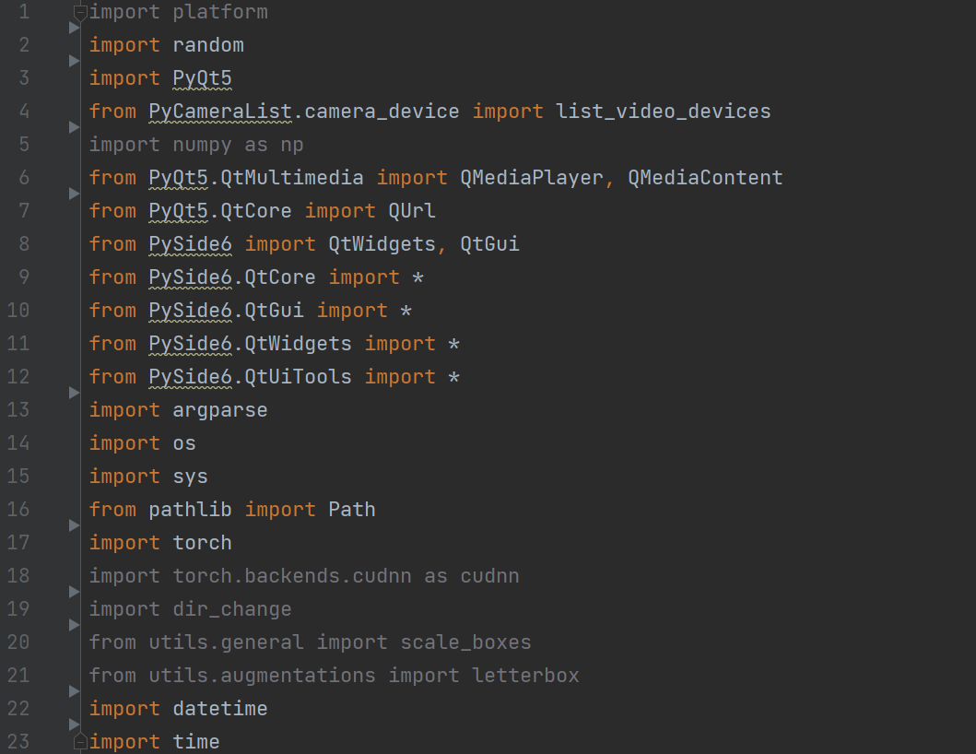

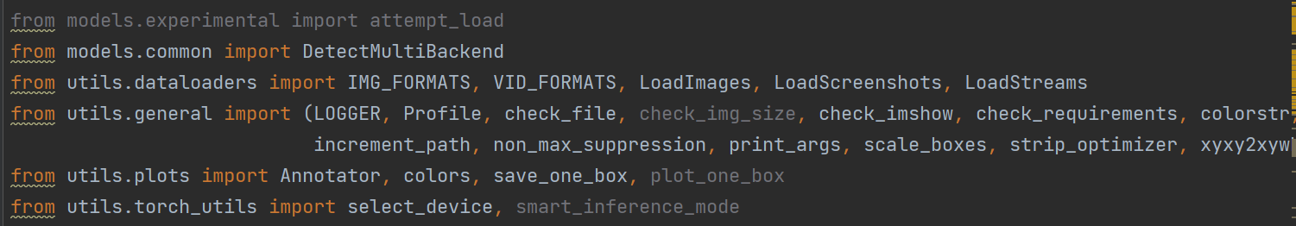

This code includes numerous Python packages that are significant to support functions like data processing, image processing, machine learning, and the creation of graphical user interfaces (GUIs). In addition to, these facilities have a significant impact. Here are some important libraries:

1. “platform”: This library is used to retrieve detailed data of the OS, such as the operating system name, release, structure, etc. This is very beneficial for crafting cross-framework code. One can customize your code in accordance with the OS.

2. “random”: The library is employed to create random numbers. It is countless instances where one might have to create random values. For example rearranging data within the field of machine learning, or creating unpredictable occurrences as seen in game development.

3. “PyQt5” and “PySide6”: These two libraries are libraries designed for GUI development. These two are both Python connectors of the Qt framework, a platform-independent application development framework. Both of these libraries assist you develop advanced graphical applications.

4. “numpy”: It is among the vital scientific calculation modules for Python script. It offers a vast array for mathematical calculations. In addition to resources for handling that involve extensive arrays and mathematical structures. In both data analysis and artificial intelligence, numpy is crucial.

5. “torch”: This represents the PyTorch software, an open source library for ML and DL. This offers numerous utilities and functions to construct and train deep learning networks. This offers an adaptable and effective method to develop and instruct neural networks models. In this program, it is applied to import the model and execute inference.

6. “argparse”: The “argparse” package is employed for parse command line inputs. In numerous scripts written in Python, it is possible that you must obtain parameters from the terminal. The argparse module is useful for managing the given parameters conveniently.

7. “os” and “sys”: These two libraries provide many operating operating systemtem level functions. One can utilize to handle files and folders, obtaining environment variables, working with paths, and various other features.

8. “pathlib”: This package offers an class-based approach for managing file directory paths. This more convenient and offers a more instinctive interface than the os.path module.

9. “datetime” and “time”: The two libraries are used to handle dates and times. One can utilize these to obtain the present time, perform calculations involving time, customize the appearance of time, and similar functionalities.

10. “cv2” is Python integration to the OpenCV toolkit. This is a free software computer visual library. Within this program, it is utilized for reading video feed and manipulate pictures.

11. “custom models.experimental”, “custom models.common”, “custom utils.dataloaders”, “special utils.general”, “bespoke utils.plots”, “special utils.torch_utils” are custom modules that may contain some features specific to this project. As an illustration, “the models in the experimental section” might include several experimental models. “helper.dataloaders” may contain certain functions for importing data, etc.

The significance of these resources is that they supply multiple potent functionalities that enable programs to complete intricate assignments with a decreased amount of code. As an illustration, assuming numpy is not installed, it might be necessary to write extensive code for array and matrix manipulation within specific code segments. In case you lack PyTorch, it might be necessary to compose both the forward and backward propagation of artificial neural networks from square one. Many programming to build the user interface. Hence, this software can vastly increase your effectiveness in development.

### **9.2.2 UI manage**

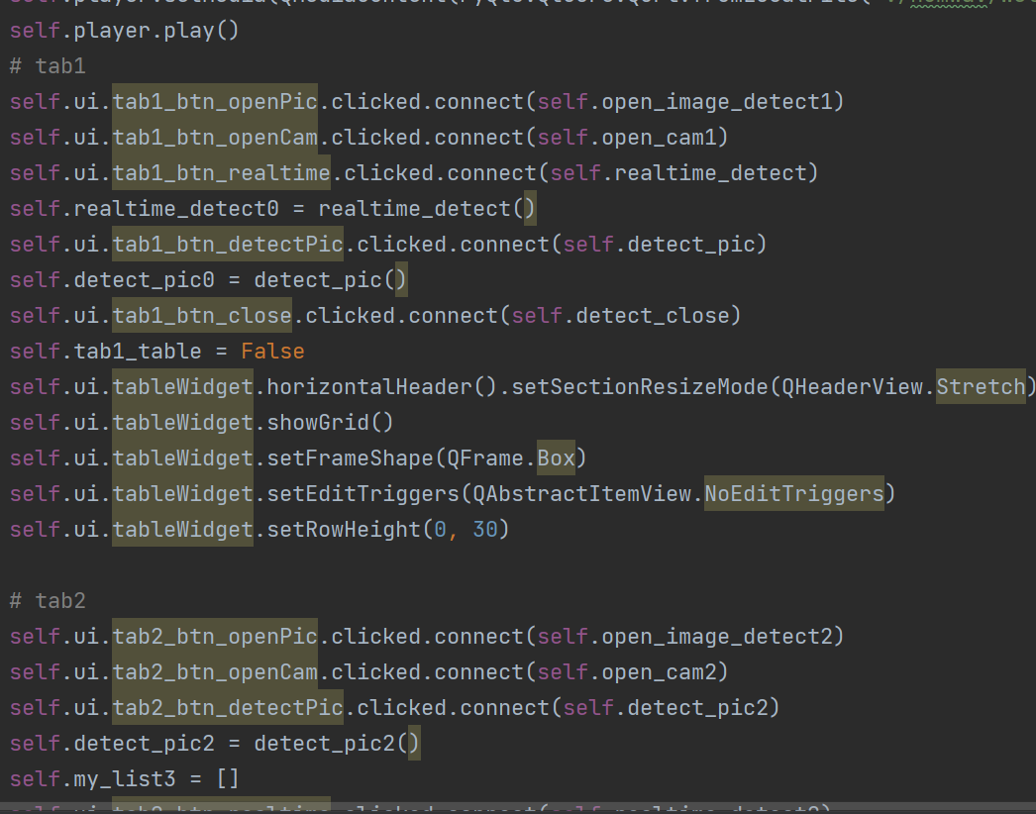

The code implements a class with the name `number_detect0`. This is mainly utilized to create and controlling a user-friendly interface The graphical user interface includes several tabs (tabbed areas). All tabs includes a few buttons which can activate various functions. Below is a detailed explanation of each part:

1. `__init__` function: It is the class initializer within the class. The procedure will be triggered whenever a fresh `number_detect0` object is created. In this procedure, a user interface file is initially loaded. Next, a few variables and items are prepared.

2. `self.ui = QUiLoader().load("D:\\Python\\YOLO-number\\num_detect.ui")`: This piece of code loads an interface file, that specifies the graphical user interface layout and appearance.

3. `self.b = 1`, `self.Cap = 0`, `self.n = 1`, etc.: These lines assign initial values to certain variables that could be utilized later in the code.

4. `self.player = QMediaPlayer()`: This statement in the code instantiates a an object of type `QMediaPlayer`. This can be utilized for enjoy audio and video recordings.

5. `self.player.setMedia(QMediaContent(PyQt5.QtCore.QUrl.fromLocalFile("./numwav/Welcome.wav"))`: This statement of programming code defines the media of the media player object for playing a locally stored audio file.

6. `self.player.play()`: This piece of code initiates the audio playback.

7. `self.ui.tab1_btn_openPic.clicked.connect(self.open_image_detect1)`, etc.: These lines of code connect the click events of various buttons with the corresponding functions. This enables the controls to initiate the required operations after being pressed. Once the user chooses these controls, the relevant methods are executed.

8. `self.ui.tableWidget.horizontalHeader().setSectionResizeMode(QHeaderView.Stretch)`, etc.: These code lines define various properties of the table, including column adjustment mode, grid display, border shape, edit trigger, etc. This code guarantees that the table columns will be adjusted to fit the available space.

9. `self.ui.tab5_label_1.setFont(font)`, etc.: These lines of code change the font and label's color.

### **9.2.3 Detection model processing**

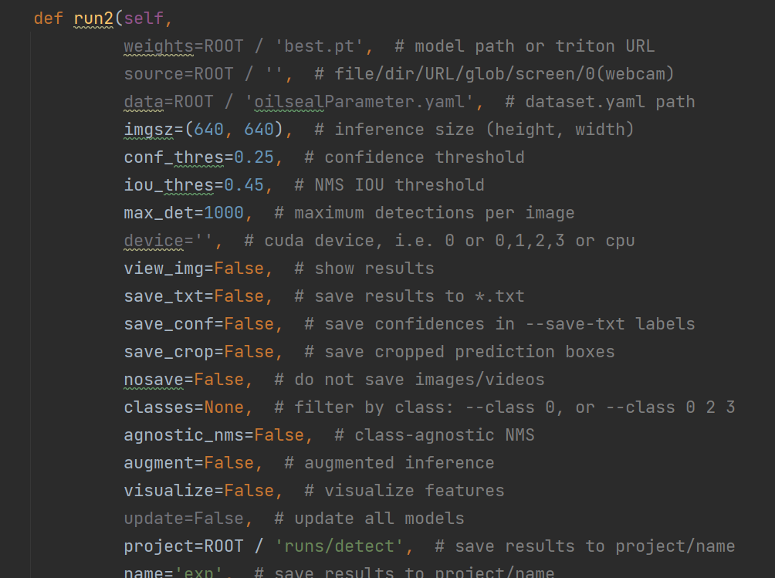

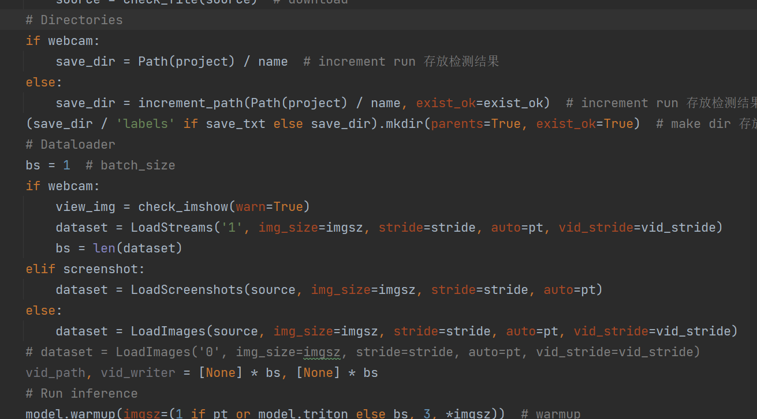

The source code defines a subroutine named run2. This program executes a model used for object recognition and analyzes the findings.

Function parameters: The specified parameters are utilized for set the operation mode of the software. They include the directory of the model parameters, data source, picture dimensions, certainty threshold, intersection over union threshold for non-maximum suppression, platform selection, whether to show the output, and whether to store the output.

Data Loading: Based on the kind of the input origin (webcam, screenshot or other) pick different data importing approaches.

Model warmup: Apply the model.prepare() function for pretrain the model.

Process predictions: For every picture within the collection, produce estimations and analyze the results. This consists of maximum suppression for the predictions, saving predictions to a file, combining predictions with images, and similar operations.

Result Stream: In case the input source comes from a webcam, the edited image is returned.

### **9.2.4 Open the image for detection**

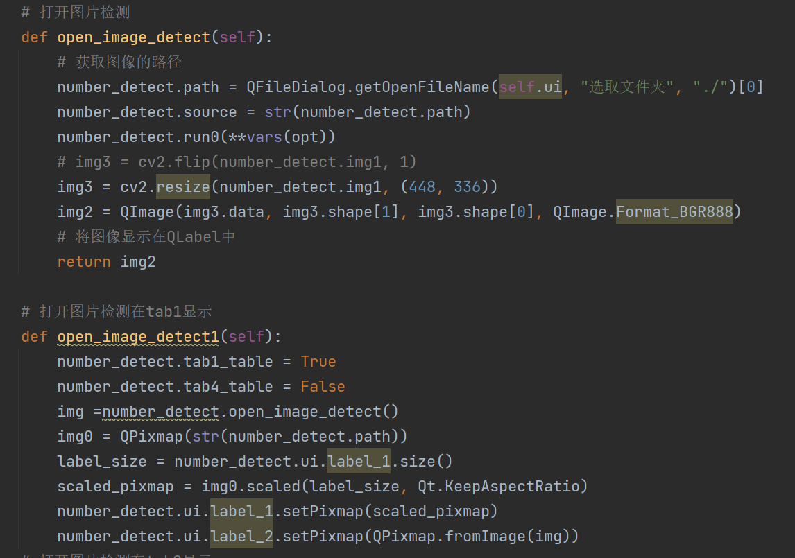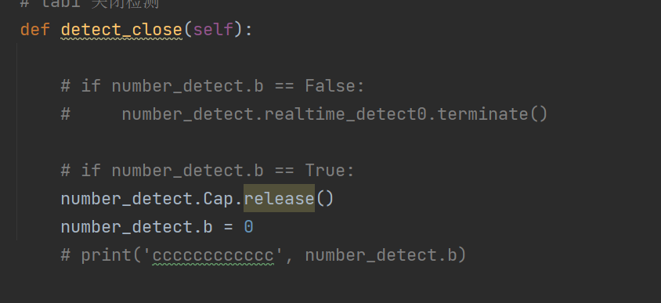

This code defines three functions, all of which are used to open and display images in the graphical user interface (GUI). These functions use the Qt library, a library for creating graphical user interfaces.

open_image_detect function: This function first uses the QFileDialog.getOpenFileName method to open a file dialog box and let the user select a file. Then, it calls the run0 method to run the object detection model. Finally, it converts the processed image into a QImage object for display in Qt's GUI.

open_image_detect1 function: This function first calls the open_image_detect function to obtain the processed image. It then uses a QPixmap object to load the original image and scale it to the size of the QLabel. Finally, it displays the original image and the processed image in a QLabel.

### **9.2.5 Random Algorithm Generation**

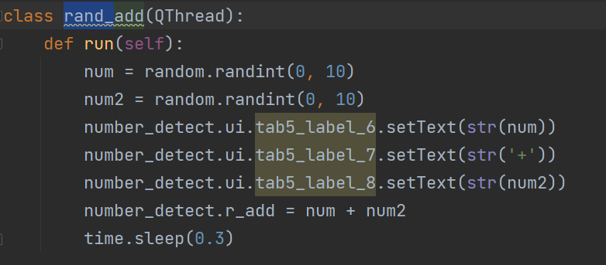

Every class inherits from from QThread and employed to carry out tasks in separate threads. These four categories are employed to generate random sum, difference, multiplication and division problems correspondingly.

rand_add class: Creates a random math problem using a separate thread. Initially produces two random values from 0 to 10. Next, the application exhibits the arithmetic equation on the graphical user interface. In conclusion, the computation is performed the final value and records it in the variable number_detect.r_add.

rand_sub class: Creates a random subtraction question in a newly created thread. To start with produces a random whole number from 0 to 10. Next, it creates an unpredictable integer from 0 to this particular integer. Afterwards, it shows the subtraction equation on the graphical user interface. Lastly, the calculation is performed the outcome and keeps the information in number_detect.r_sub record.

rand_mul class: Creates a random multiplication question in a separate thread. Initially, creates two unpredictable whole numbers ranging from 0 to 10. After that, it presents the math equation on the GUI screen. In conclusion, the computation is performed the final answer and stores the data in the variable number_detect.r_mul.

rand_division class: Creates a randomized division task in a new process. Initially produces a random whole number ranging from 1 through 99. Next, it locates every divisor of this integer value. Afterwards, it chooses at random one of these variables as the dividing factor. Subsequently, it shows the mathematical division in the user interface. In conclusion, the calculation is done the outcome and stores it in the allocated space number_detect.r_division.

### **9.2.6 Real-time detection thread**

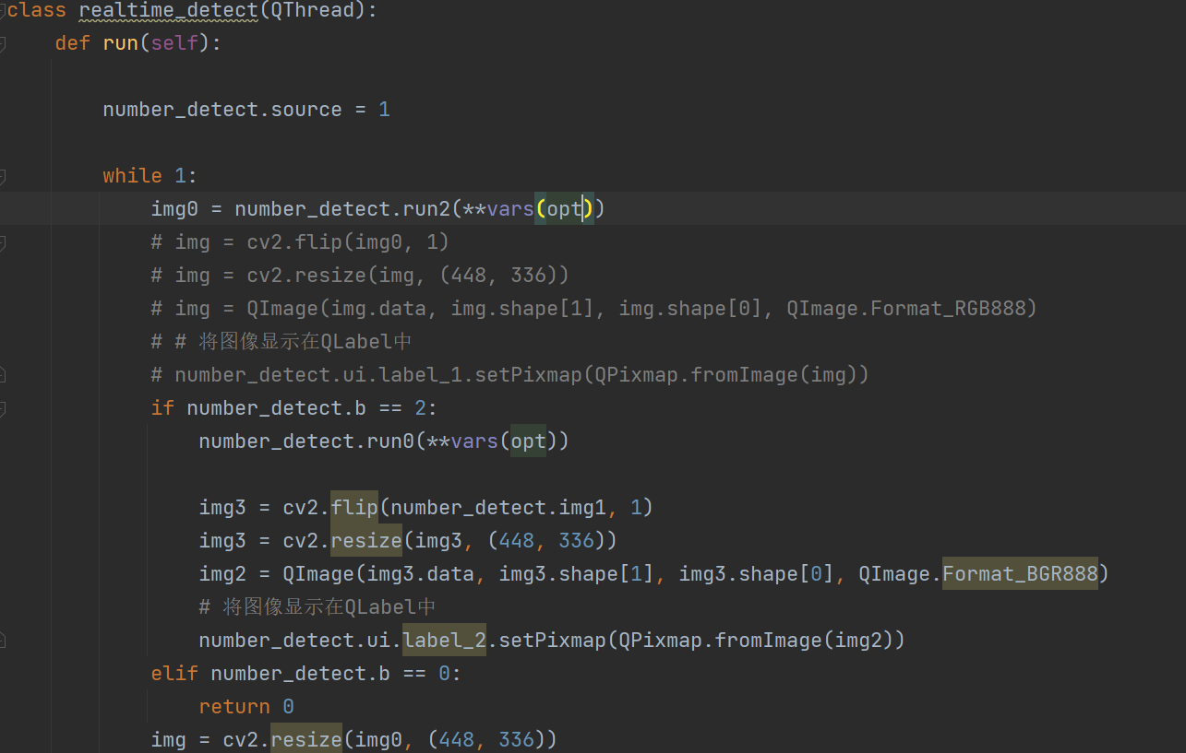

This code defines a class named realtime_detect, which is a subclass of QThread and is used to run real-time detection tasks in a new thread.

In the run method, first set number_detect.source to 1, indicating that the camera is used as the input source. Then it enters an infinite loop, constantly performing real-time detection.

In each cycle, the number_detect.run2 method is first called for real-time detection, and the detected image img0 is obtained.

Then perform different operations according to the value of number_detect.b:

If number_detect.b is 2, it means that a static detection is required. At this time, the number_detect.run0 method will be called to perform static detection, and then the detected image will be displayed on label_2.

If number_detect.b is 0, it means that real-time detection needs to be stopped. At this time, the loop will exit and the thread will end.

Finally, display the real-time detected image on label_1.

### **9.2.7 Processing Expressions**

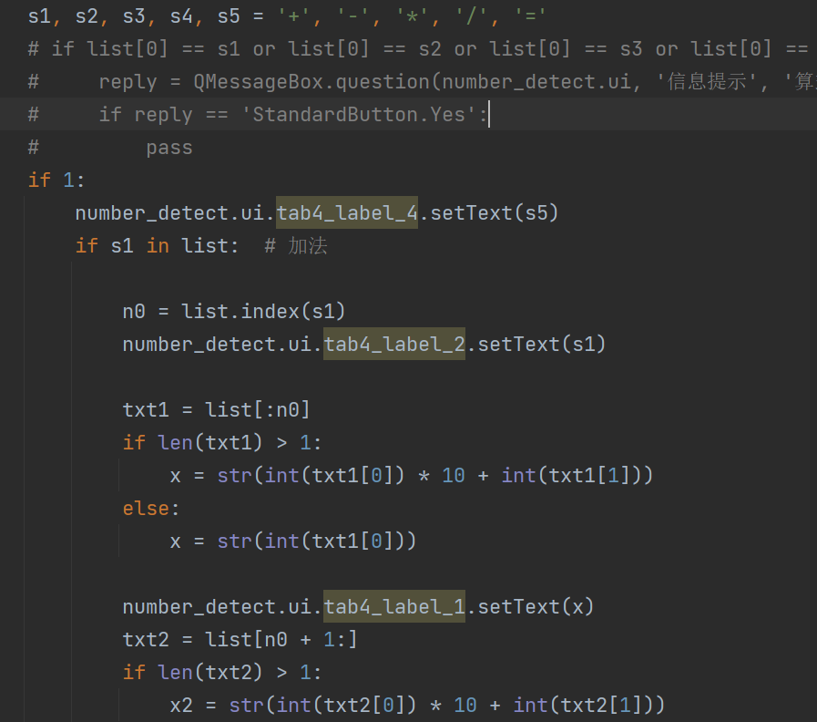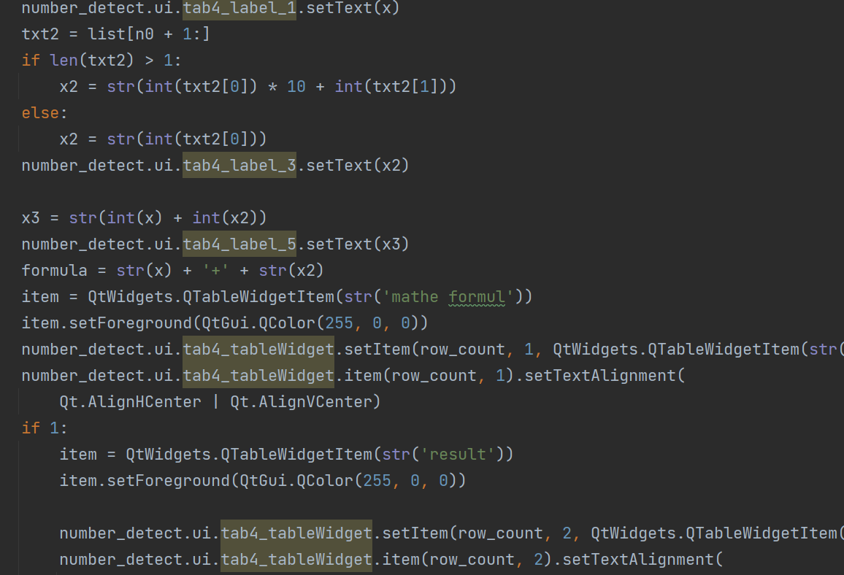

This code is used for calculating mathematical formulas. The first step is to declaring five character variables that symbolize addition, subtraction, multiplication, division, and the equal sign.

Then it verifies if if the initial item inside the given sequence matches any of these five characters. In case it is, it will display a prompt to notify the user that the formula contains a mistake and requires rewriting and verification.

Next, it checks the list for addition, subtraction, multiplication, and division characters and acts accordingly:

In case the array includes another character, it discovers the location of this character. Next, it will utilize the item preceding it as the initial parameter and the component that follows it as the secondary input. Following the execution the mathematical sum, the outcome will be shown the result on the screen.

In case the array includes a hyphen, it discovers the position where this character is. Next, it is going to utilize the preceding element as the initial operand and the subsequent element as the second argument. Following the execution of subtracting the outcome will be exhibited the result in the user interface.

In case the array includes a multiply sign, it will discover the index of this symbol. This will utilize the preceding element that as the initial value and the following element the same as the succeeding value. The system will subsequently execute the process of multiplying and show the final result on the display.

In case the array includes a splitting symbol, it can locate the location of this character. This will utilize the preceding element it to function as the initial value and the subsequent element it as the second input. The program will subsequently execute the process of division and show the solution on the user interface.

### **9.2.8 Voice Broadcast**

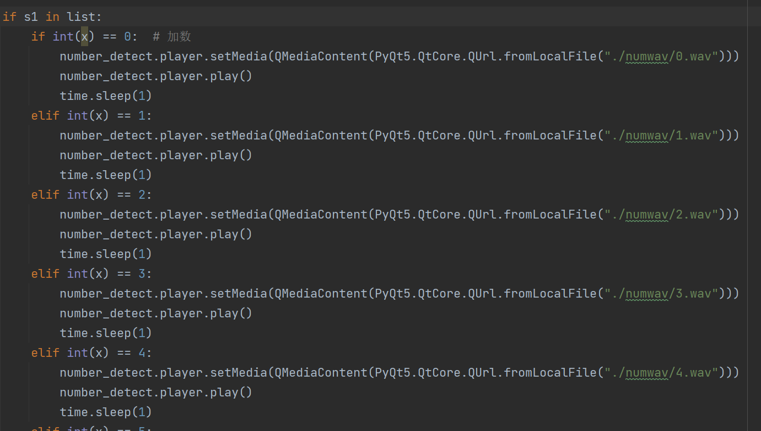

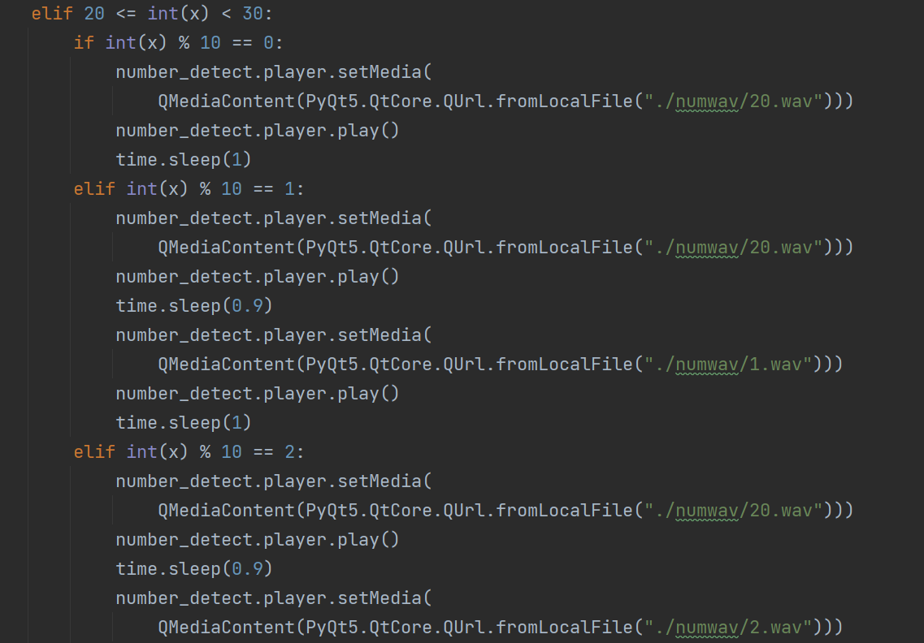

This is the voice broadcast part of the program. According to the number detected by the program, the corresponding voice audio file is read aloud. The algorithm in this part is very simple to explain. From the part of 0-20, the corresponding number can be read aloud. After it is greater than 20 , first judge the size of the first number, such as the number 25, the first number will be checked first, if it is 2, it will read 20 first, and then read the second number, which can simplify the code and reduce the drag due to heavy code program speed. But this part is still the part that takes up the most lines.

### **9.2.9. Database**

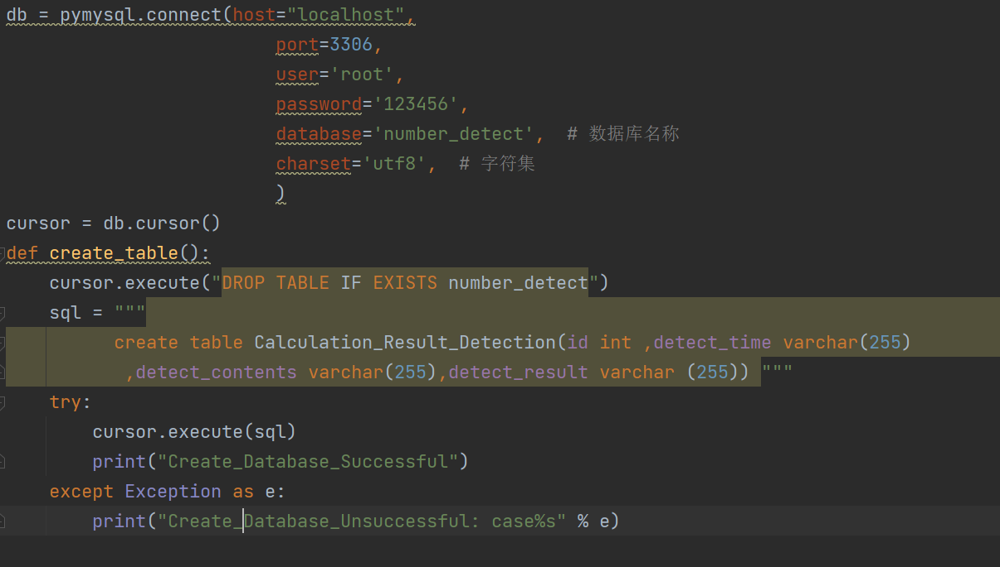

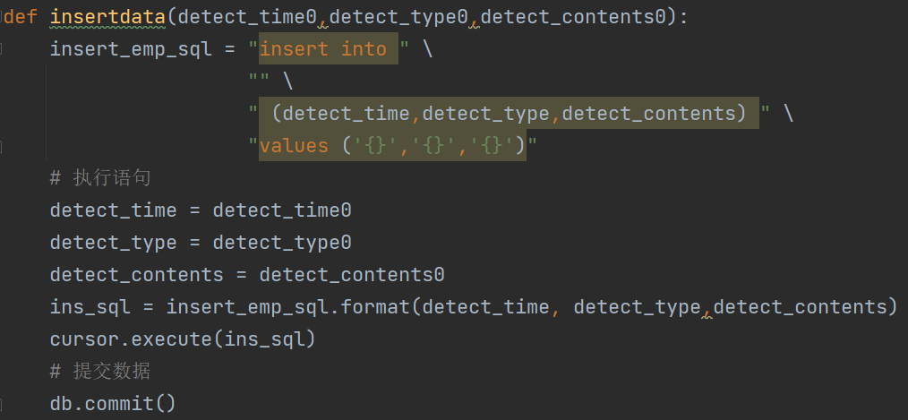

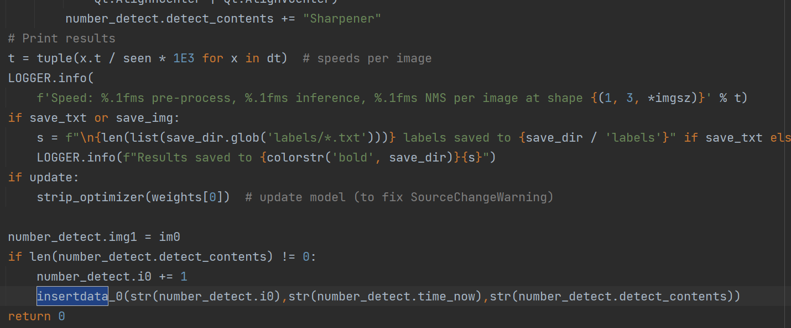

The above figure is an example. The database creation of the program encapsulates the function of storing data into the database, and calls the database. Before storing the data in the database, there are different verifications for each function. For example, functions 1 to 3 can only store the detected response items, numbers or characters. For function 4, the complete formula will be stored, and for function 5, besides the formula, the judgment of right and wrong will also be stored.

# **10. CHAPTER 10: SYSTEM VALIDATION**

## **10.1 UI Testing**

|  |  |  |  |  |
| --- | --- | --- | --- | --- |
| ID | Test Case | Expected Outcome | Actual Outcome | Pass/Fail |
|  | Jump between functions | Smooth jump, no freezes or error pages | As expected | Pass |
|  | open camera button | If the camera is connected, it will prompt that the camera is successfully opened, and a pop-up window will prompt that the camera is successfully opened.  If the camera is not connected, it will prompt that the camera failed to open, and a pop-up window will prompt that the camera cannot be opened normally. | As expected | Pass |
|  | Real-time detection button | Clicking the button will display the camera screen, then the button works normally | As expected | Pass |
|  | Capture screen button | Click the button to capture a frame of camera picture and display it | As expected | Pass |
|  | End detection function | Click to end detection, no real-time detection of images | As expected | Pass |
|  | Upload picture function button | Click to pop up the file selection window | As expected | Pass |
|  | Generate Calculation Button - Addition | generate random formula | As expected | Pass |
|  | Generate Math Button - Subtraction | generate random formula | As expected | Pass |
|  | Generate formula button - Multiplication | generate random formula | As expected | Pass |
|  | Generate calculation button - Division | generate random formula | As expected | Pass |

Through the button test list, it can be seen that the UI is working normally, there is no problem of wrong access to the buttons, and each button click can react to make the program active, then it is necessary to carefully test whether the program functions are implemented as scheduled.

## **10.2 Function Testing**

|  |  |  |  |  |
| --- | --- | --- | --- | --- |
| ID | Test Case | Expected Outcome | Actual Outcome | Pass/Fail |
|  | Detect Model Accuracy Tests - Stationery | It has high accuracy for the detection of a single stationery and can detect object categories | As expected | Pass |
|  | Detect Model Accuracy Tests - Symbols | It has high accuracy for the detection of a single symbol and can detect the type of symbol | As expected | Pass |
|  | Detect Model Accuracy Tests - Numeric | It has high accuracy for the detection of a single number and can detect the size of the number | As expected | Pass |
|  | Detect Model Accuracy Tests - Formula | The detection of the entire formula has high accuracy, and the formula can be detected, so that the calculation | As expected | Pass |
|  | Open camera function test | The camera is successfully opened, and a pop-up window will notify that the opening is successful. If it is not connected, it will display that the camera is not detected, and the opening fails | As expected | Pass |
|  | Real-time detection function test | It can display the camera screen, and detect the content in the image in real time, and accurately select and mark all stationery and calculation formulas | As expected | Pass |
|  | Intercept real-time detection screen function test | Capture the content of the camera and display it on the right side of the real-time monitoring window, select the detected item, and if it is a single number or character, the corresponding voice will be broadcast | As expected | Pass |
|  | Upload picture function test | After clicking, a file selection pops up to select a computer file for detection. Just like capturing the content of the camera, select the detected item, and if it is a single number or character, the corresponding voice will be broadcast | As expected | Pass |
|  | System Computing Ability Test | Test the computing power of the system, can calculate the detected formula and get the correct result | As expected | Pass |
|  | Functional Test of Randomly Generated Algorithms | Randomly generate addition, subtraction, multiplication and division within ten | As expected | Pass |
|  | Voice broadcast function test | After detecting a numeric character or calculating a formula, the corresponding voice will be broadcast, and if it is a formula, the entire formula will be read aloud | As expected | Pass |
|  | End detection function test | After the end of the detection click, stop using the camera and release the camera | As expected | Pass |
|  | Database | Corresponding information will be stored after detection | As expected | Pass |

## **10.3 User Acceptance Testing**

For the User Acceptance Testing, tests will be conducted for different groups. For the tests, their privacy will be protected, and no personal information will be disclosed.

And effective User Acceptance Testing will bring many positive benefits, such as the usability of the program and whether it can meet the needs of various groups of personnel.

### **10.3.1 A teenager**

|  |  |  |
| --- | --- | --- |
| **Test Case** | **Answer/ Evaluate** | **Rating** |
| **Functional experience**  -Whether the function is comprehensive  -Whether such a functional design can meet the learning needs of children | There are many functions, and the five functions have different purposes, which should be able to satisfy all stages from the foundation of mathematics to calculation.  It should be able to meet the arithmetic calculation learning needs of preschool children to elementary school | Good |
| **User interface experience**  - Interface look and feel  - Does the interface feel stuck? | The interface is very simple, with only the necessary buttons. However, although it may have the original intention of preventing children from being distracted, it is difficult to attract children's interest at once. There is no lag in the interface, which is an advantage. The jump between interfaces and the response speed of buttons are no problem. | Fair |
| **Accuracy**  - Whether the detection is accurate  - Is there any misidentification | The detection accuracy is good without any errors, but it seems to sometimes identify extra objects if the surrounding environment is too noisy. | Good |
| **Voice broadcast**  -Whether the pronunciation is clear and accurate  - is there more fun | This function is something I didn't expect. The pronunciation is very clear, and it is easy to understand the pronunciation of numbers and symbols and can read calculations aloud. This is a very eye-catching existence in the program in my opinion. It does make for more fun. | Good |
| **Ease of use**  - Is it easy to use  -Is it difficult to use | It is very easy to learn how to use, even if there is no tutorial, you can operate and use the software without any obstacles after a few minutes of groping, and there is almost no difficulty in using it. | Good |
| **Overall feeling**  -Whether it can help children learn mathematics  - Is it novel and interesting enough? | I think it can help children learn basic mathematics. I have not seen a similar educational program designed in this way on the market. It is the first time I have seen image detection used in mathematics education. | Good |

### **10.3.2 Mother of a preschool child**

|  |  |  |
| --- | --- | --- |
| **Test Case** | **Answer/ Evaluate** | **Rating** |
| **Functional experience**  -Whether the function is comprehensive  -Whether such a functional design can meet the learning needs of children | It feels very good. From the simplest identification of stationery to learning numbers and characters, children should be able to understand the writing and pronunciation of numbers step by step.  It feels that it can be used as an auxiliary tool in children's mathematics learning. | Good |
| **User interface experience**  - Interface look and feel  - Does the interface feel stuck? | I think the simplicity of the interface is good to avoid distracting children, but too simple is too boring for children who are too young, and I don't agree with this.  The interface fluency is very good, very smooth, no lag. | Fair |
| **Accuracy**  - Whether the detection is accurate  - Is there any misidentification | The accuracy is quite high, and both object numbers and characters can be recognized more accurately.  Just for a moment, the plus sign was recognized as 4. It seems that the handwriting is not regular enough and there will still be inaccurate problems. | Good |
| **Voice broadcast**  -Whether the pronunciation is clear and accurate  - is there more fun | Very good function, very interesting, and the pronunciation is relatively full and accurate. I think this is indeed a feature of the program that is more attractive to children. | Good |
| **Ease of use**  - Is it easy to use  -Is it difficult to use | It is relatively simple for me to use. I don’t know if children can learn it easily. Sometimes the detection needs to adjust the position of the paper and the angle of writing. Although this is unavoidable, there are still some inconveniences. It would be better to be able to improve. | Good |
| **Overall feeling**  -Whether it can help children learn mathematics  - Is it novel and interesting enough? | Very nice and I would love to have my kids use this program to aid their learning in the future. It should be able to help children understand well and standardize writing.  Very novel program, enough to attract me to use. | Good |

### **10.3.3 A 7-year-old child**

|  |  |  |
| --- | --- | --- |
| **Test Case** | **Answer/ Evaluate** | **Rating** |
| **Functional experience**  -Whether the function is comprehensive  -Whether such a functional design can meet the learning needs of children | I feel that there are many functions, but I don't know how to use the latter functions, and I don't know how to write calculations yet.  I think the front function is very interesting, I can take out my stationery to see which one they are, I write the number as it is and it will read it to me.It feels that it can be used as an auxiliary tool in children's mathematics learning. | Fair |
| **User interface experience**  - Interface look and feel  - Does the interface feel stuck? | It's not good looking, the interface is too boring, and there will be fruits or small animals in my textbooks.  It doesn't feel stuck. | Bad |
| **Accuracy**  - Whether the detection is accurate  - Is there any misidentification | Very accurate, I took out the pencil and it showed the correct amount. I'm not very good at writing numbers, but I know them and it reads to me as soon as I write it, and it feels accurate. | Good |
| **Voice broadcast**  -Whether the pronunciation is clear and accurate  - is there more fun | It's fun, it reads very clearly, I can understand it, she will tell me how to say the number, but I also know how to say it. | Good |
| **Ease of use**  - Is it easy to use  -Is it difficult to use | The former functions are very simple, I will use them, and the latter ones may be learned later. | Good |
| **Overall feeling**  -Whether it can help children learn mathematics  - Is it novel and interesting enough? | I feel that it will help me learn to write numbers. This is the first time I play this kind of software, and I have never used this kind of software that can read pictures. It's fun, and I'd love to play it. | Good |

## **10.4 Summary**

This system verification process was carried out through three primary phases. These steps include Front-end Testing, Integration Testing, and UAT.

During the UI Testing step, the application's user interface underwent testing for its promptness, capabilities, and error resolution. Each and every examinations were completed without any issues. This shows that the user interface is operating as predicted without any difficulties.

The Functional Testing phase concentrated on the fundamental capabilities of the system. This system underwent testing to determine its precision in finding and classifying diverse entities, icons, and numerals. Additionally, it evaluated for its capacity to execute instant detection, record screens, post pictures. Moreover, testing was conducted to evaluate its aptitude to execute mathematical operations. Every examination succeeded, which shows that the program's operations are operating as intended.

The final testing phase included the testing the software with various groups of users. Included in this were an adolescent, a mom with a toddler, and a child aged seven. The participants assessed the platform using its performance, UI experience, precision, vocal communication, user-friendliness, and overall perception. This platform got favorable reactions from every user. It was mentioned that it's intuitive, precise, and helpful for acquiring mathematical knowledge.

To sum up, the process of validating the system has shown that the system is performing as desired and is positively received by the intended user base. The UI of the system is efficient and flawless, its capabilities are correct and trustworthy. It supplies an excellent user interface. Thus, the software is set for implementation and utilization in actual environments.

# **11. CHAPTER 11: CONCLUSION AND REFLECTIONS**

## **11.1 Critical Evaluation**

To begin with, concerning this program, we must carefully consider and assess. Although it performs well in many aspects, there are numerous areas deserving of our enhancement and flawlessness.

Each part of the application possesses its benefits and drawbacks. The advantage of the software function is that it uses image recognition technology to help children learn mathematics, and the five functions ranging from easy to difficult can satisfy the learning demands in mathematics of kids at various learning phases. In addition, the accuracy of image detection is furthermore very high, and various formulas can be accurately recognized. However, there are present additionally, some disadvantages. The accuracy of formula recognition suffers when writing materials and mathematical equations appear together. This can have a negative impact on children's learning experience; thus, we must discover a solution to address this.

In terms of user interface, although it adopts a clean style, it might seem somewhat boring for the preschool education field. A clean interface has its advantages, it allows users to focus more on educational material instead of getting diverted by sophisticated interface features. However, for preschool children, what they need may be richer and more interesting visual stimuli to grab their focus and foster their curiosity for education. Therefore, this program may need to make some improvements in the user interface design, such as adding more animation effects, using brighter colors, or introducing gamified components to improve children's learning interest and active involvement.

In addition, the voice broadcast provided by the additional function is also a standout feature. Although currently only numbers with a maximum value less than or equal to 100 can be broadcast, the implementation of this capability vastly boosts the pleasure of studying and attracts children's interest. This is a very valuable feature, but perhaps we could consider extending it to transmit bigger figures, or even certain elementary mathematical expressions.

Overall, this app has great potential in helping children learn math, but some key areas require enhancements and optimization to fulfill the requirements of users more effectively. We look forward to seeing its further development and believe it will play a crucial function within the realm of edtech.

## **11.2 Summary and Conclusion**

In conclusion, the project in question provides an exceptional learning tool utilizing the potential of image recognition technology to enhance children's mathematics learning. It is designed with a range of functionalities, from simple to complex, to cater to the diverse learning needs of young ones during different periods of their academic path.

The software's strength is based on its capability to accurately recognize and interpret mathematical formulas, offering a distinct, interactive, and captivating educational journey. The inclusion of a voice broadcast feature further enhances the educational journey, making it more enjoyable and appealing for young students.

However, similar to other groundbreaking solution, it is not without its obstacles. One of the key issues identified is the decrease in formula recognition accuracy when stationery objects and mathematical formulas are simultaneously presented. This is a technical hurdle that must be resolved to ensure the software's effectiveness and dependability.

The UI, despite being tidy and uncomplicated, would gain from further improvements. In the context of preschool education, a more vibrant and visually engaging interface could be more effective in attracting and maintaining youngsters' concentration. Incorporating more animated effects, brighter colors, and gamification elements can greatly enhance user engagement and learning achievements.

Despite these challenges, the initiative carries tremendous prospects. It represents a novel approach to making mathematics more accessible and enjoyable for children, which could have a deep effect on their educational achievements and continuous learning process. With further refinement and optimization, this software has the potential to become an important asset within the domain of instructional technology.

In summary, this project is a testament to the transformative power of technology in education. It underscores the potential of integrating advanced technologies like image recognition into learning tools to create more engaging, interactive, and effective learning experiences for children.

# **12. REFERENCES**

1. Hu, B., Zhou, H., & Cai, T. (2020). The effect of parental involvement on autonomy and relatedness in Chinese adolescents: The mediating role of perceived autonomy support from parents. Current Psychology, 1-10.
2. Puan, Y. H., Jaafar, N. I., Mohd Hanafiah, N., & Yusoff, N. (2020). Academic stress and its associated factors among Malaysian students. Journal of Taibah University Medical Sciences, 15(2), 134-141.
3. Tan, S. K., & Chua, Y. P. (2019). Creativity and self-efficacy of Malaysian primary school students. International Journal of Academic Research in Progressive Education and Development, 8(4), 77-86.
4. Wang, M., Zhang, X., Chen, Q., Wang, Z., Zhang, W., & Sun, J. (2019). The effects of extracurricular tutoring on children’s creativity, intrinsic motivation, and anxiety. Frontiers in Psychology, 10, 1-10.
5. Wang, Y., Fu, J., Liu, Y., Chen, Y., & Han, X. (2020). Parental expectation and children's life satisfaction: The moderating role of academic achievement. Child Indicators Research, 13(1), 139-154.
6. Wong, K. J., Othman, A., & Razali, R. (2021). Predictors of anxiety and depression symptoms among Malaysian secondary school students. Malaysian Journal of Medicine and Health Sciences, 17(1), 75-82.
7. Wu, J., Li, X., Li, X., Li, Y., Liang, Y., & Li, C. (2020). Academic pressure and depression among Chinese adolescents: The role of negative life events and coping styles. Journal of Affective Disorders, 263, 216-223.
8. Bodrova, E., & Leong, D. J. (2017). The importance of being playful. American Educator, 41(1), 29-37.
9. Duncan, G. J., Dowsett, C. J., Claessens, A., Magnuson, K., Huston, A. C., Klebanov, P., ... & Japel, C. (2007). School readiness and later achievement. Developmental Psychology, 43(6), 1428-1446.
10. Geary, D. C., Hoard, M. K., Nugent, L., & Bailey, D. H. (2012). Adolescents’ functional numeracy is predicted by their school entry number system knowledge. PLoS One, 7(10), e46650.
11. Ginsburg, H. P., & Ertle, B. (2008). Learning mathematics in early childhood: Paths toward excellence and equity. In C. Howes, B. E. Vaughn, & R. A. Pianta (Eds.), Research on the education of young children (pp. 45-82). Lawrence Erlbaum Associates.
12. Pellegrini, A. D., & Smith, P. K. (1998). Physical activity play: The nature and function of a neglected aspect of play. Child Development, 69(3), 577-598.
13. Bodrova, E., & Leong, D. J. (2017). Tools of the mind: The Vygotskian approach to early childhood education (3rd ed.). Pearson.
14. Duncan, G. J., Dowsett, C. J., Claessens, A., Magnuson, K., Huston, A. C., Klebanov, P., ... & Japel, C. (2007). School readiness and later achievement. Developmental psychology, 43(6), 1428-1446. doi: 10.1037/0012-1649.43.6.1428
15. Geary, D. C., Hoard, M. K., Nugent, L., & Bailey, D. H. (2012). Adolescents’ functional numeracy is predicted by their school entry number system knowledge. PLoS ONE, 7(10), e46640. doi: 10.1371/journal.pone.0046640
16. Ginsburg, H. P., & Ertle, B. (2008). Young children's understanding of counting and cardinality. In J. S. Gaskin (Ed.), Proceedings of the 30th annual conference of the North American Chapter of the International Group for the Psychology of Mathematics Education (pp. 291-299). Retrieved from <https://eric.ed.gov/?id=ED535067>
17. Pellegrini, A. D., & Smith, P. K. (1998). Physical activity play: The nature and function of a neglected aspect of play. Child Development, 69(3), 577-598. doi: 10.1111/j.1467-8624.1998.tb06145.x
18. Fitzgerald, R., & Guerin, S. (2016). Personalizing early learning through intelligent technologies: Opportunities and challenges. Journal of Early Childhood Research, 14(4), 324-338. doi: 10.1177/1476718X15625401
19. Plowman, L., & Stephen, C. (2005). Children, play, and computers in pre-school education. Routledge.
20. Ullah, I., Siddiqui, M. F., Khan, M. A., & Aslam, M. (2020). An analysis of machine learning based education for early childhood development. In 2020 International Conference on Smart Systems and Artificial Intelligence (ICSSAI) (pp. 191-196). IEEE. doi: 10.1109/ICSSAI49166.2020.9338577
21. Chen, M. Y., Hsiao, H. S., & Lai, C. L. (2021). The effect of using programming-based teaching system software on the computational thinking of young children. Computers in Human Behavior, 121, 106861. <https://doi.org/10.1016/j.chb.2021.106861>
22. Diamond, A., & Lee, K. (2011). Interventions shown to aid executive function development in children 4 to 12 years old. Science, 333(6045), 959-964.
23. Li, J., & Zhu, Y. (2020). Preschool children's attention span: age, gender, and environmental factors. Frontiers in Psychology, 11, 2215.
24. National Association for the Education of Young Children. (2012). Executive function: Implications for education. Retrieved from https://www.naeyc.org/resources/pubs/yc/may2012/executive-function-imply-education
25. Zelazo, P. D., & Carlson, S. M. (2012). Hot and cool executive function in childhood and adolescence: Development and plasticity. Child Development Perspectives, 6(4), 354-360.
26. Li, X., Liang, Y., & Liang, Y. (2020). Research on Application of Image Recognition Technology in Primary Mathematics Teaching. International Journal of Emerging Technologies in Learning, 15(11), 89-102.
27. Bhatia, R., Kumar, M., & Sharma, N. (2020). A Comparative Study of Traditional and Image Recognition Based Math Learning. Journal of Engineering Education Transformations, 34(3), 346-353.
28. Huang, C. C., Chen, Y. Y., & Chen, C. W. (2019). Design and Implementation of an Interactive Mathematics Learning System Based on Image Recognition Technology. Journal of Educational Technology Development and Exchange, 12(2), 39-56.
29. Kim, J., Park, M., & Baek, Y. (2019). Analysis of Mathematical Problem-Solving Ability through Image Recognition-Based Learning. Journal of Educational Technology Development and Exchange, 12(2), 17-38.
30. Kafai, Y. B., Ching, C. C., & Marshall, S. (2013). Connected Gaming: A Framework for Developing Learning through Design Experiences with Videogames. International Journal of Game-Based Learning, 3(1), 1-16.
31. Kılıç, G. E., & Kondakci, Y. (2020). Effects of an Augmented Reality-Based Mathematics Learning Environment on Student Attitudes. Education and Information Technologies, 25(4), 3209-3226.
32. Clements, D. H. (2002). Computers in early childhood mathematics. Contemporary Issues in Early Childhood, 3(2), 160-181. https://doi.org/10.2304/ciec.2002.3.2.6
33. Haugland, S. W. (2000). Computers and young children. ERIC Clearinghouse on Elementary and Early Childhood Education. https://eric.ed.gov/?id=ED441522
34. Heft, T., & Swaminathan, S. (2002). Technology and young children in the 21st century: A review of research. Journal of Research on Technology in Education, 34(3), 250-261. https://doi.org/10.1080/15391523.2002.10782326
35. Katz, L. G., & Chard, S. C. (2000). Engaging children's minds: The project approach (2nd ed.). Ablex.
36. Li, Y., & Ma, Y. (2010). Integrating technology into classroom teaching: A conceptual framework. Journal of Educational Technology Development and Exchange, 3(1), 1-14. https://www.researchgate.net/publication/285140346_Integrating_Technology_into_Classroom_Teaching_A_Conceptual_Framework
37. Plowman, L., & Stephen, C. (2003). A "benign addition"? Research on ICT and pre-school children. Journal of Computer Assisted Learning, 19(2), 149-164. https://doi.org/10.1046/j.0266-4909.2003.00016.x
38. Siraj-Blatchford, I., & Siraj-Blatchford, J. (2006). A sociocultural approach to learning in the early years. Routledge.
39. Van Scoter, J., & Smith, K. (2015). Preschool children's use of technology at home and school. Childhood Education, 91(2), 107-113. <https://doi.org/10.1080/00094056.2015.1022899>
40. Clements, D. H., & Sarama, J. (2018). Mathematics in early childhood: Learning paths toward excellence and equity. Routledge.
41. O'Halloran, L., Barnes, A., & Brown, T. (2019). Using image recognition technology to support children's learning of geometry in preschool. Computers & Education, 139, 1-11.
42. Zhang, Y., & Wang, S. (2020). Using image recognition technology to support preschoolers’ spatial awareness learning. International Journal of Emerging Technologies in Learning, 15(13), 100-115.
43. Clements, D. H., & Sarama, J. (2011). Early childhood mathematics intervention. Science, 333(6045), 968-970. doi: 10.1126/science.1204530
44. Fuson, K. C., & Hall, J. W. (1983). The acquisition of early number word meanings: A conceptual analysis and review. In H. P. Ginsburg (Ed.), The development of mathematical thinking (pp. 61-84). Academic Press.
45. Hirsch-Pasek, K., Zosh, J. M., Hirshberg, L. M., & Golinkoff, R. M. (2015). Implementing play-based curriculum: Fostering language and literacy development in early childhood. In S. B. Neuman & D. K. Dickinson (Eds.), Handbook of early literacy research (Vol. 3, pp. 193-208). Guilford Press.
46. Hong, H., & Hwang, M. Y. (2017). Effects of a virtual manipulative on elementary students' mathematics achievement and cognition. Educational Technology Research and Development, 65(2), 327-342. doi: 10.1007/s11423-016-9485-6
47. National Research Council. (2009). Mathematics learning in early childhood: Paths toward excellence and equity. The National Academies Press.
48. NCTM. (2018). Principles to actions: Ensuring mathematical success for all. National Council of Teachers of Mathematics.
49. Ilari, B., & von Glasersfeld, E. (2016). Teaching Mathematics to Young Children: A Practical Guide for Early Childhood Educators. Routledge.
50. Fecich, S., Brooks, K., & Robertson, C. (2019). Using Augmented Reality and Image Recognition to Engage Young Learners in Mathematics. Journal of Research in Childhood Education, 33(2), 163-176.
51. Kazakoff, E. R., Maschak, J. N., & Barron, J. M. (2016). The Role of Technology in Early Childhood Education. Journal of Early Childhood Research, 14(4), 318-329.
52. Podkowińska, P., Dąbrowska, M., & Kutt, K. (2019). Mathematics Learning through Playful Engagement with Augmented Reality. International Journal of Emerging Technologies in Learning, 14(10), 140-154.
53. Nix, S., & Treiman, R. (2019). Preschool math: The foundation for future academic success. Early Childhood Education Journal, 47(4), 509-516. doi: 10.1007/s10643-018-0941-7
54. Geist, E. A., & Guo, Y. (2021). An integrated curriculum of mathematics and computational thinking for young children. Early Childhood Education Journal, 49(1), 115-125. doi: 10.1007/s10643-020-01085-7
55. Li, C., Li, H., & Li, X. (2019). Exploration and practice of STEAM education mode based on image recognition technology. Journal of Physics: Conference Series, 1229(1), 012102. doi: 10.1088/1742-6596/1229/1/012102
56. Jia, J., Huang, J., & Liu, J. (2020). Research on Application of Image Recognition Technology in Preschool Teaching. Journal of Physics: Conference Series, 1676(4), 042115. doi: 10.1088/1742-6596/1676/4/042115
57. Jacobs, J., Kuo, P., & Franke, M. (2014). Preschool children’s attitudes and beliefs about mathematics. Early Childhood Education Journal, 42(2), 83-91.
58. Sarama, J., Clements, D. H., & Charlesworth, R. (2012). Teaching math to young children: A practice guide. National Council of Teachers of Mathematics.
59. Wang, Y., Huang, R., & Yang, Y. (2019). The effects of learning motivation and learning styles on the learning outcomes of preschool children in mathematics activities. Education Sciences, 9(3), 176.
60. University work. (2022, November 13). *Roboflow*. AI Based Automatic Stationery Billing System Data. https://universe.roboflow.com/university-work/ai-based-automatic-stationery-billing-system-data

# **13. APPENDICES**

## **Log sheets**



 







## **PPF**

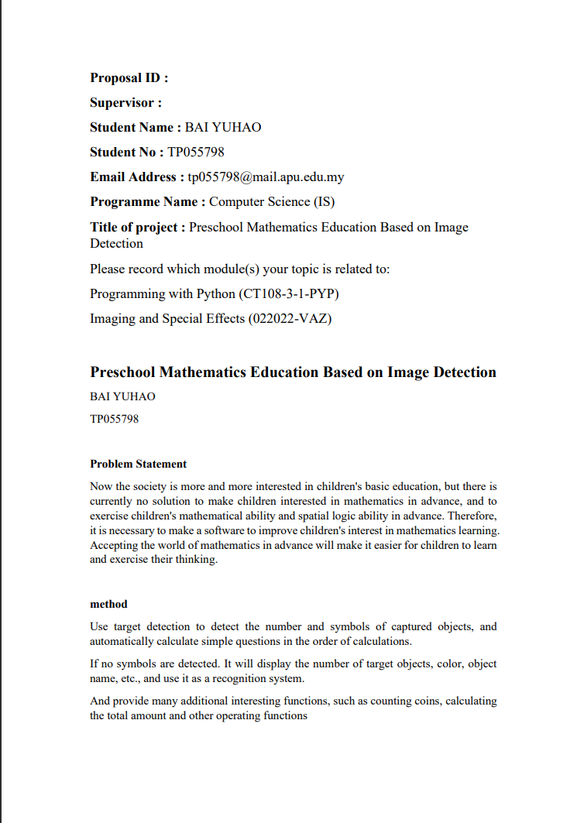

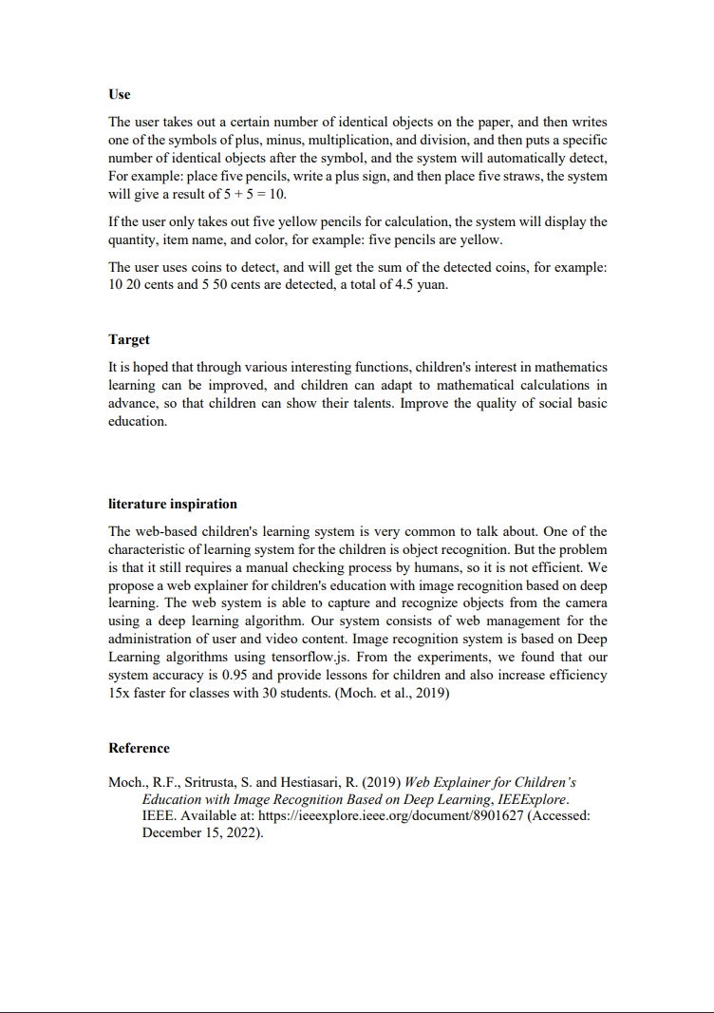

## **Ethics form**







## **Gantt chart for semester 1**

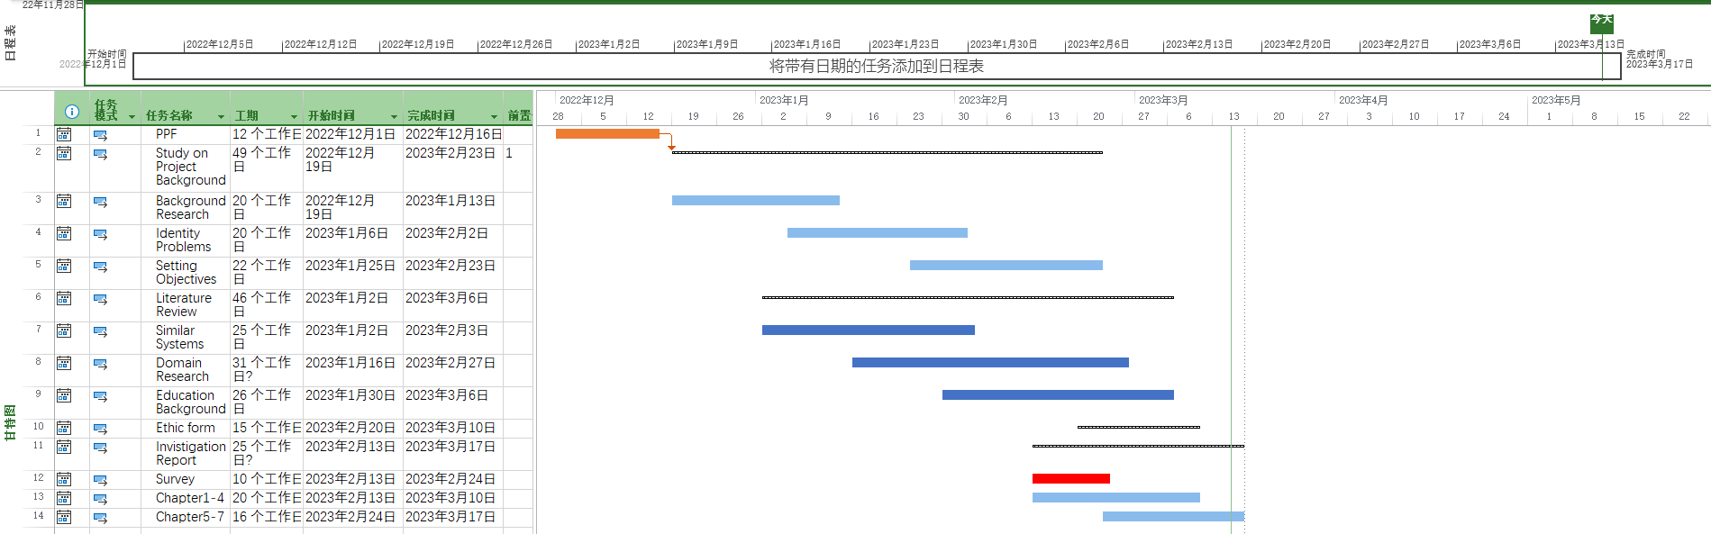

## **Gantt chart for semester 2**

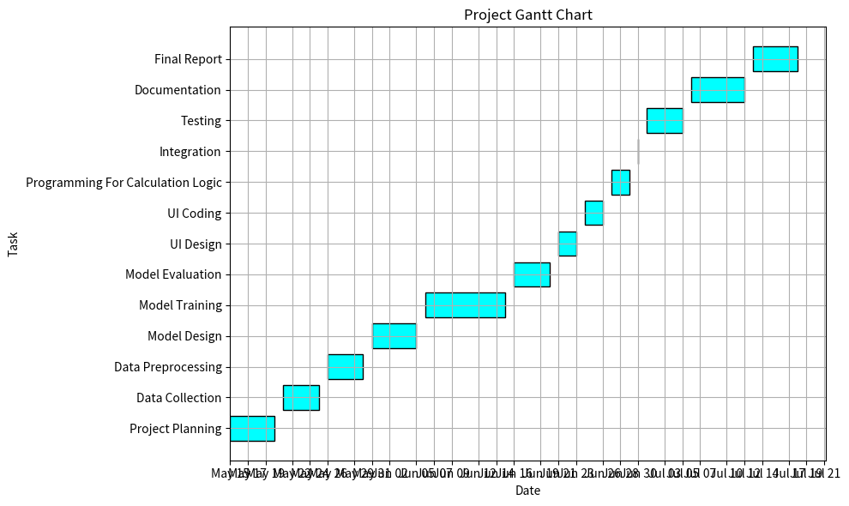

## **Poster**

